

**Warehouse Management**

**Final Release Document**

– Quy Nhon, Mar 2024 –

**Table of Contents**

I. Deliverable Package………………………………………………………………………2

II. Installation Guides………………………………………………………………………..3

III. User Manual………………………………………………………………………………3

1. Overview…………………………………………………………………………..3

2. Workflow Product…………………………………………………………………5

.3. Workflow Warehouse……………………………………………………………13

4. Workflow Category……………………………………………………………….15

5. Workflow Customer………………………………………………………………19

6. Workflow Note Delivery Goods Keeper………………………………………...23

7. Workflow Note Delivery Goods Accountant……………………………………30

8. Workflow Note Delivery Goods CFO……………………………………………36

IV. Conclusion...............................................................................................................43

# **I. Deliverable Package**

|  |  |  |
| --- | --- | --- |
| **No.** | **File** | **Notes** |
| 1 | NoteDelivery.sql | Database, including both table structures and table data |
| 2 | NoteDelivery_SRS.docx | Final SRS (Requirement) Document |
| 3 | NoteDelivery_SDS.docx | Final SDS (Design) Document |
| 4 | NoteDelivery_Backlog.xlsx | Final status for the application functions, which include:  - Function name, feature, roles, function description (changes compared to the original requirements are highlighted)  - In Charge, Planned iteration & Actual iteration  - Final status & note on the update you made  - The links to the SRS & SDS are tracked |
| 5 | NoteDelivery_Issues Report.xlsx | Final issues tracking list of the whole project |
| 6 | Test-Case-Report.xlsx | Test case and debug of program |

Other related deliverables:

· Tagged source codes: https://github.com/naca091/SWP_NoteManagement

# **II. Installation Guides**

* Environment install
* .Net 7
* Visual Studio 2022
* Microsoft SQL Server 2022
* DataBase
* Create database name: NoteDelivery
* import database NoteDelivery.sql
* Run code
* Download GitHub code: https://github.com/naca091/SWP_NoteManagement
* open code using Visual Studio 2022
* cd NoteDelivery
* dotnet run

# **III. User Manual**

## **1. Overview:**

The system to manage the issuance of invoices for shipment to agents is already available in the system.

The system includes three main roles: Warehouse Keeper, Accountant and Director. Corresponding to each role will include the following functions:

**Warehouse Keeper:**

* Product Management:
* Manage product quantity
* If the product is almost out of stock, if it is out of stock, you can put that product in the queue until the product is back in stock.
* Edit product information if there are errors.
* Download product lists as Excel files at any time.
* Manage category of product
* After creating a product category, add or edit the product’s classification.
* View details and edit classification information if there are errors
* Warehouse management:
* Create a new warehouse
* View and edit warehouse information if there are errors
* Customer management:
* Add, edit and view detailed customer information. Customers cannot edit phone numbers because they rely on phone numbers to accumulate customer reward points.
* Rank customers based on reward points (1 point = 1$)

There are 5 ranking levels:

Bronze: condition < 100,000 points

Silver: conditions: 100,000 < points < 200,000 points

Gold: conditions: 200,000 < points < 500,000 points

Platinum: conditions: 500,000 < points < 1,000,000 points

Diamond: condition: > 1,000,000 points

**Accountant:**

* Create new accounts for employees in the system: create accounts for new employees in the system and assign employee rights in the system
* Approve Note Delivery Goods phase one:
* After the warehouse keeper creates the warehouse delivery note, the accountant will approve it and send it to the director for final approval. If the accountant has not approved, the director cannot agree/disapprove the delivery note.

**Director (CFO):**

* Approve phase two of Note Delivery Goods . After being approved by the director, the warehouse keeper will see the ticket in the "Approved" status and proceed to release the product. If the director does not approve the delivery note, the note will be in the "Disapproved" status.
* Create new roles for employees in the system: director creates new roles for employees in the system.

**The system's Dashboard page includes the following information:**

* Total amount earned from product sales
* Total number of customers in the system
* The number of delivery notes is waiting for the director's approval

**Auxiliary features:**

* Security and tracking:
* Ensure information security with access management measures based on employee roles and data encryption
* Provides the ability to track the history of creating delivery notes, query the date of creation and print delivery notes
* User interface UI:
* Our system provides a user-friendly interface that allows users to create, edit, and view warehouse delivery notes with ease. The design of the interface is intuitive and straightforward, ensuring that users can navigate and perform tasks efficiently.
* Moreover, the interface is designed to be compatible across multiple platforms, from desktop computers to mobile devices. This cross-platform compatibility ensures that users can access and use the system anytime, anywhere, providing convenience and flexibility.

## **2. Workflow product**

* **Viewing Product Information:** The main part of the page shows a table of products. Each row represents a product and includes its name, price, quantity, product code, warehouse, category ID, and product image. You can view the information of each product directly from this table.

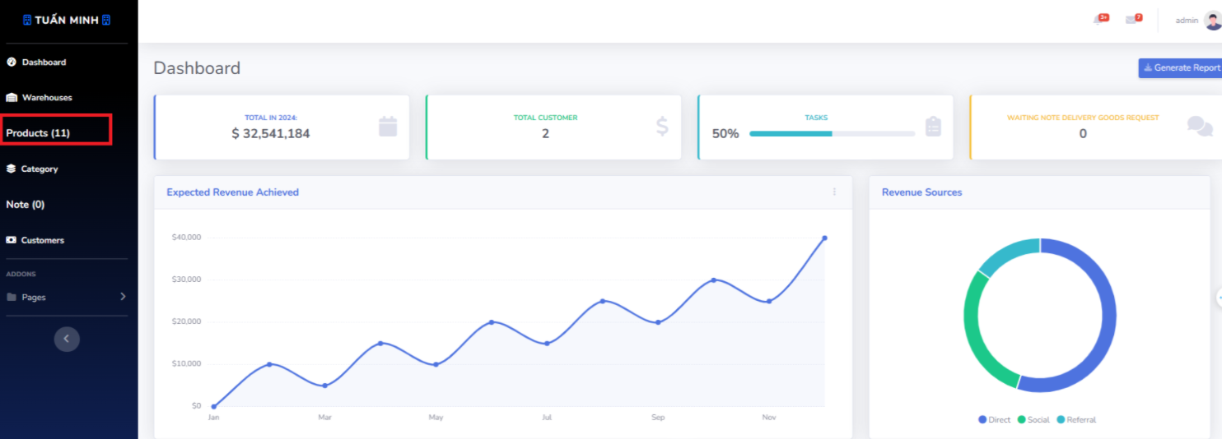

* **Editing a Product:** To edit the information of a product, locate the product in the table and click the “Edit” button in its row. This will take you to a new page or pop-up window where you can modify the product’s details.

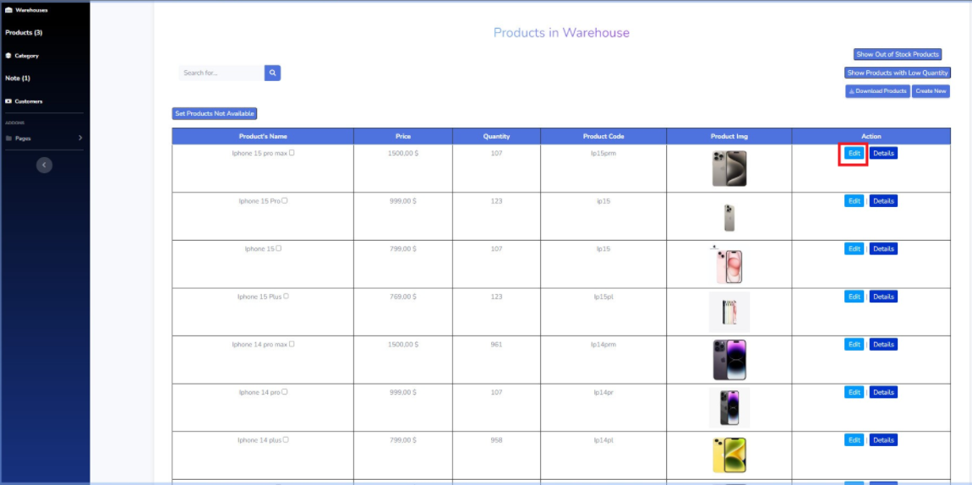

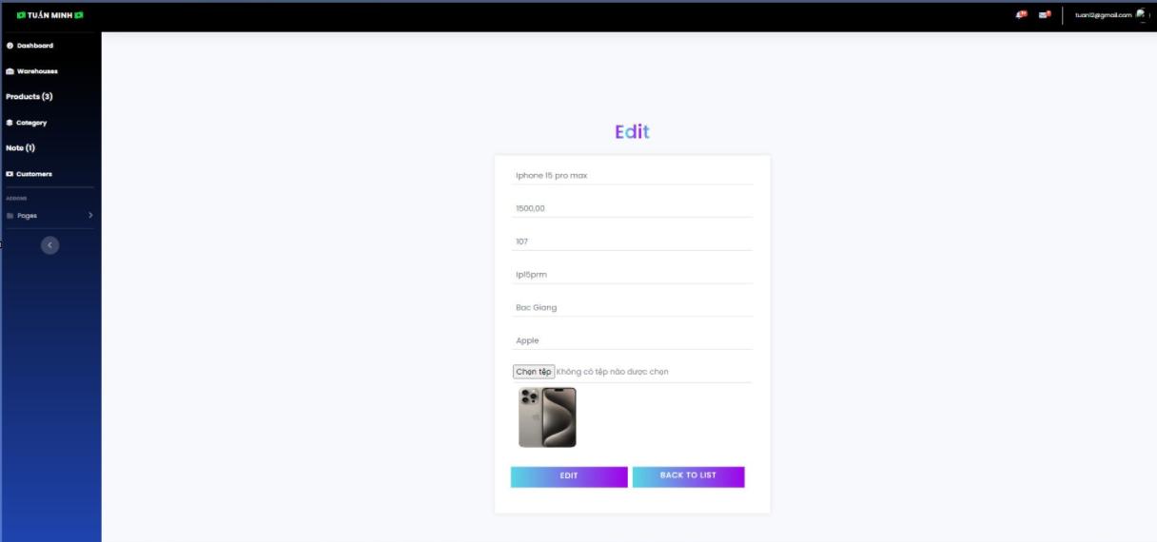

* **Viewing Product Details:** To view more details about a product, click the “Details” button in the row of the product. This will take you to a new page or pop-up window that displays more detailed information about the product, such as its full description, specifications, and images.

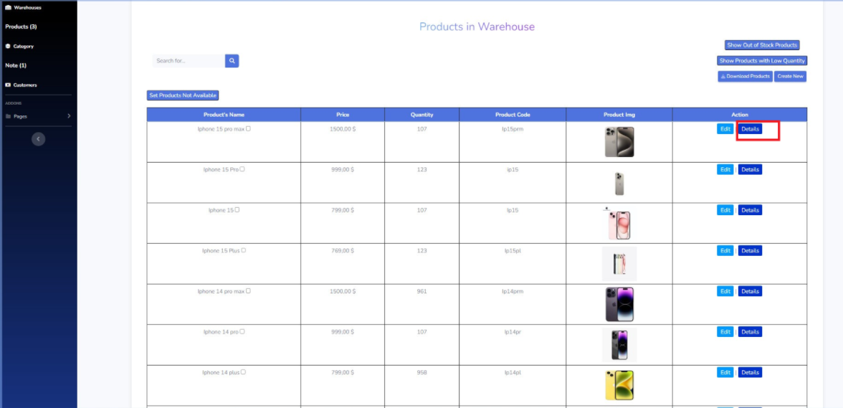

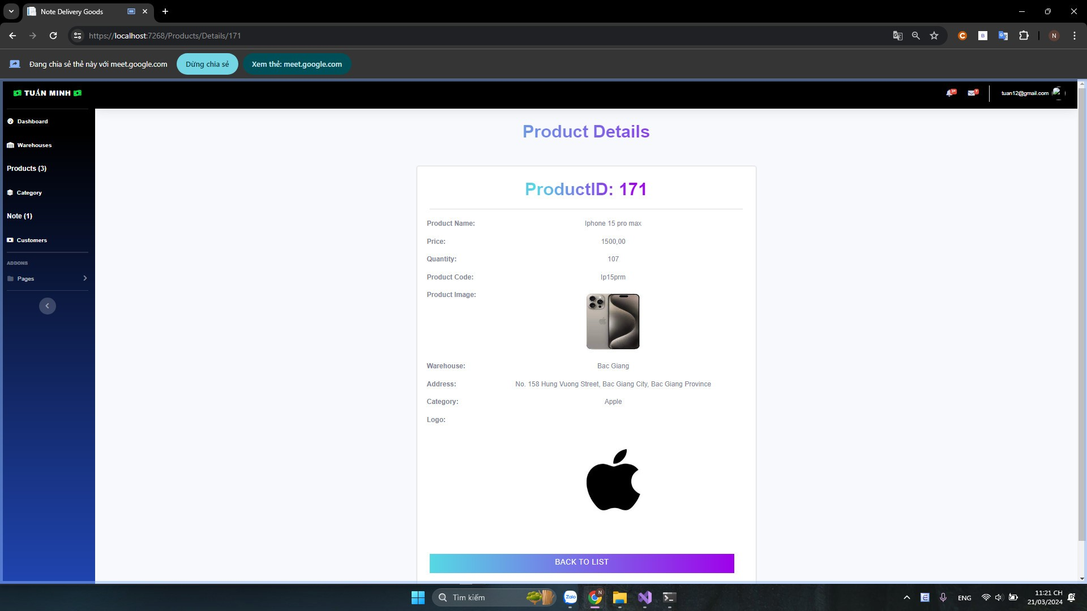

* **Displaying Products with Low Quantity:** If you want to view products with a quantity below 10, click the “Show product with low quantity” button. The product table will update to only display products with a quantity below 10.

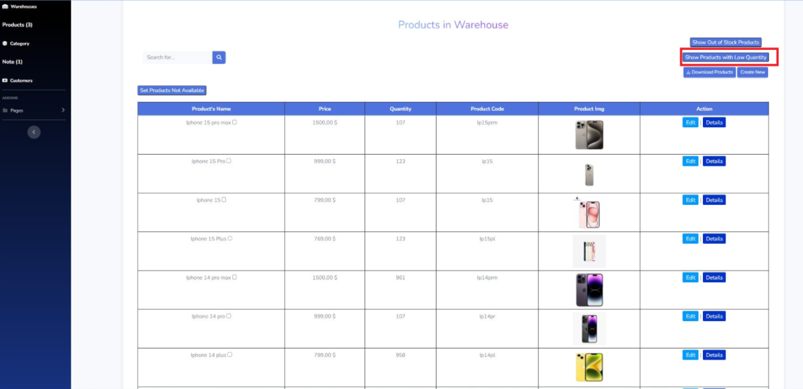

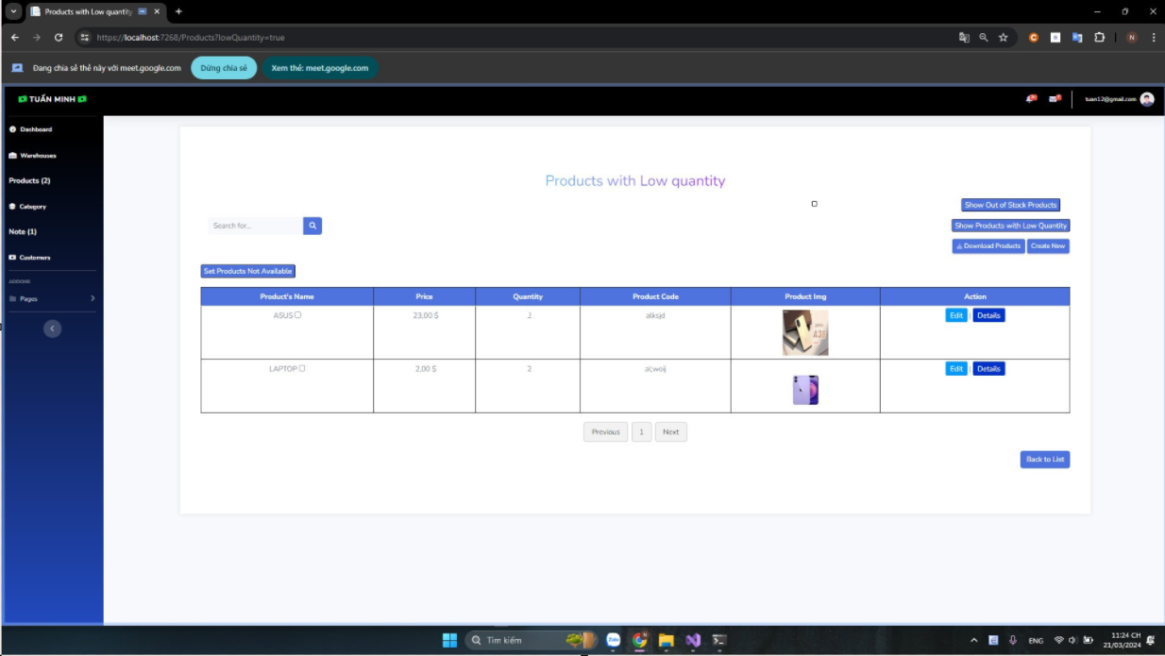

* **Setting Product as Not Available:** If you want to mark a product as not available, click the “Set product not available” button. The product will be marked as not available and moved to the out of stock product list.

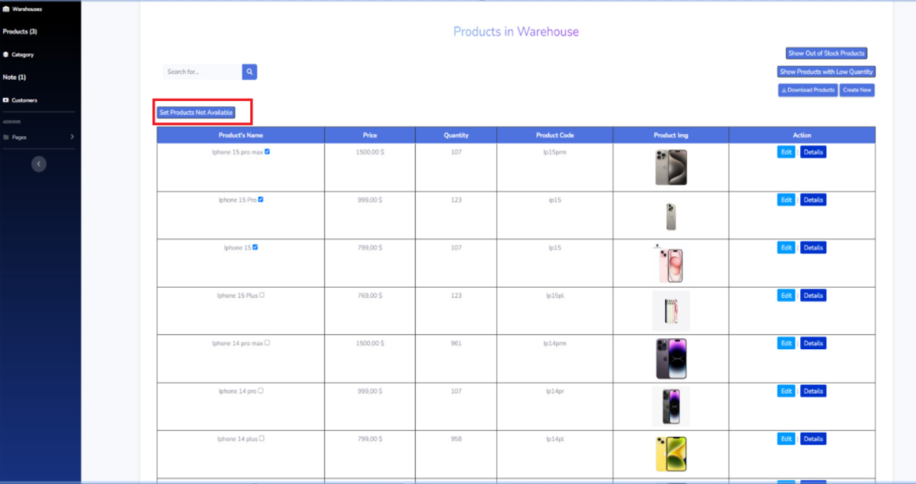

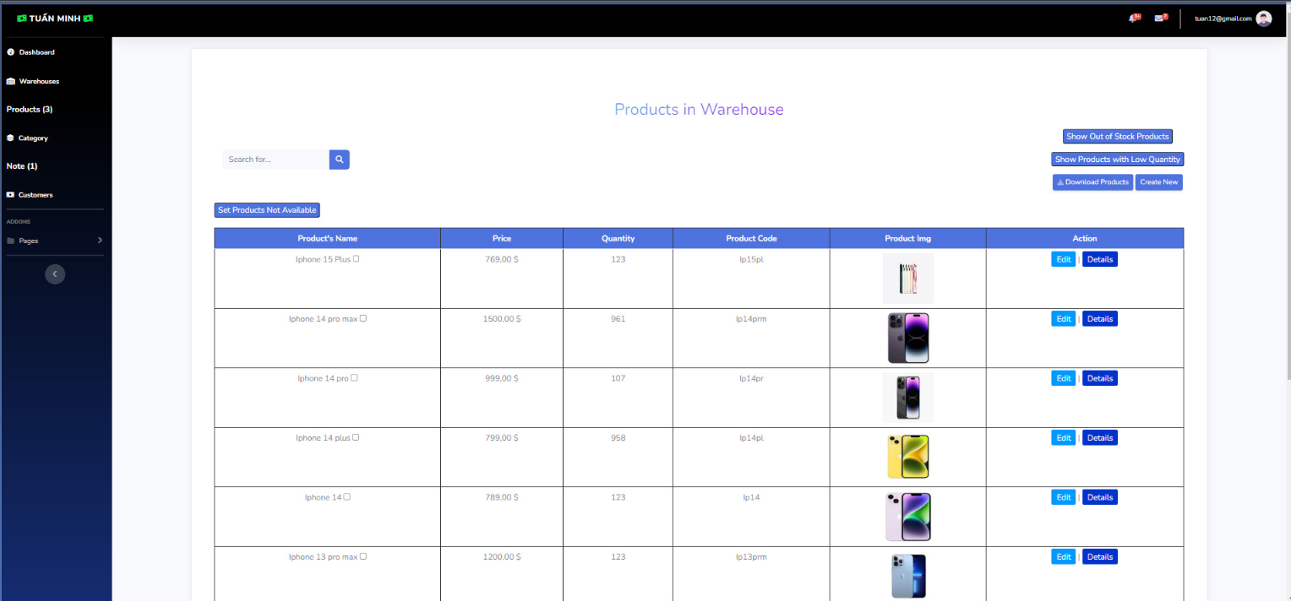

* **Displaying Out of Stock Products:** If you want to view products that are out of stock, click the “Show out of stock products” button. The product table will update to only display products that are out of stock.

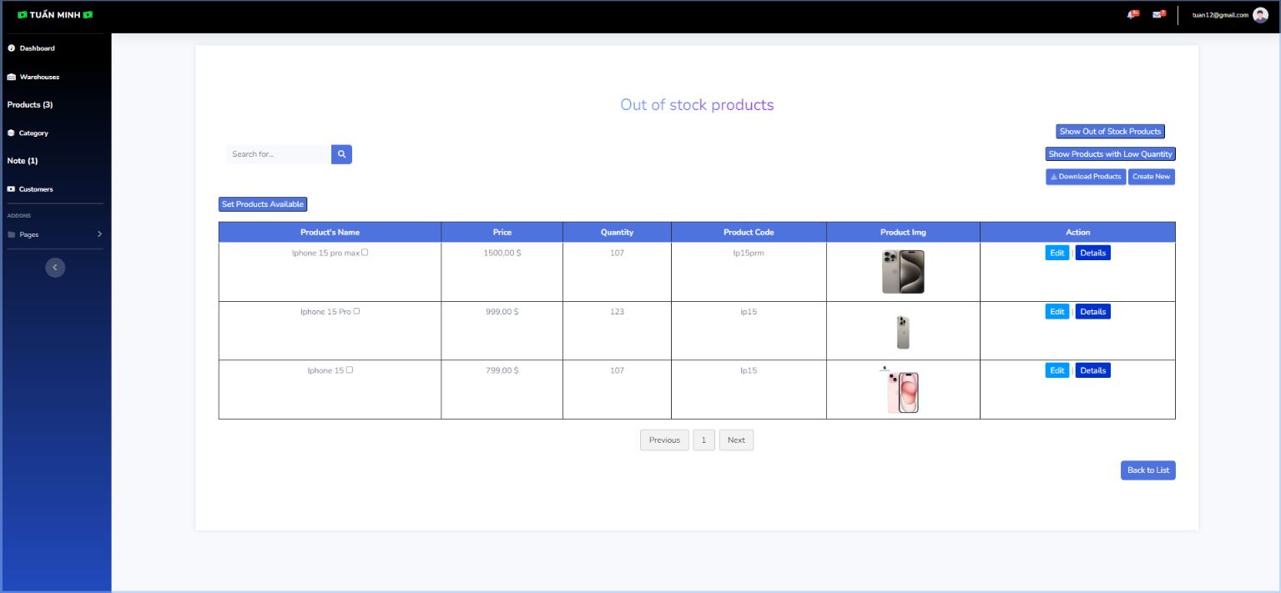

* **Set product available:** When selecting products on the page showing out-of-stock products, click "order available products". The selected products will move to the list of products.

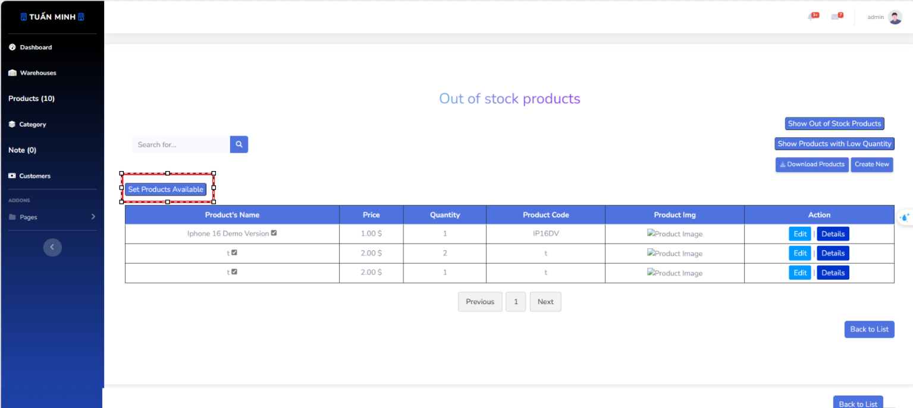

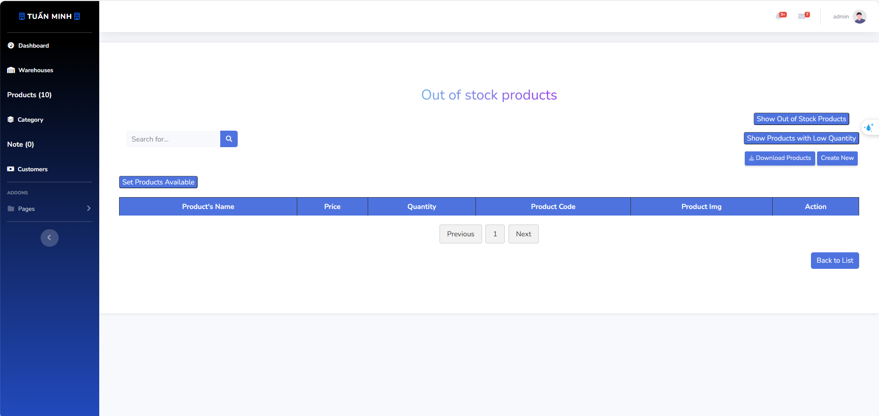

* **Downloading Product Information:** Click the “Download product” button at the top of the page to download the detailed information of all products as an Excel file.

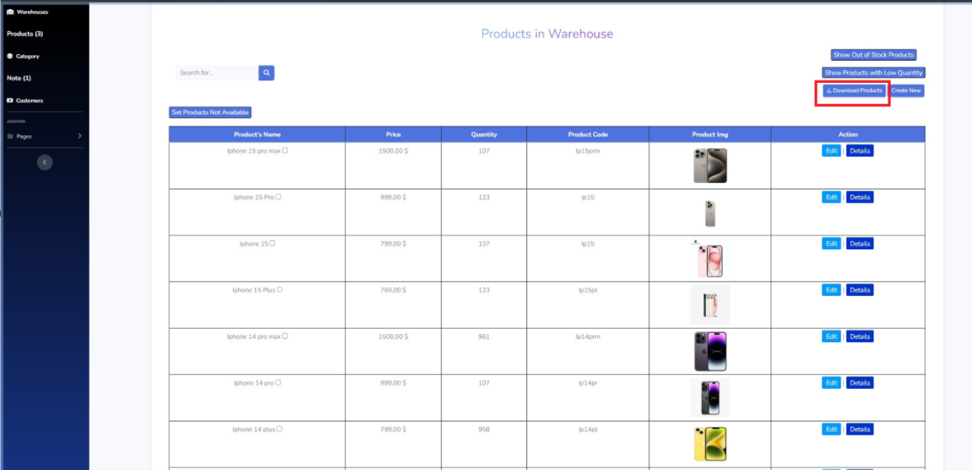

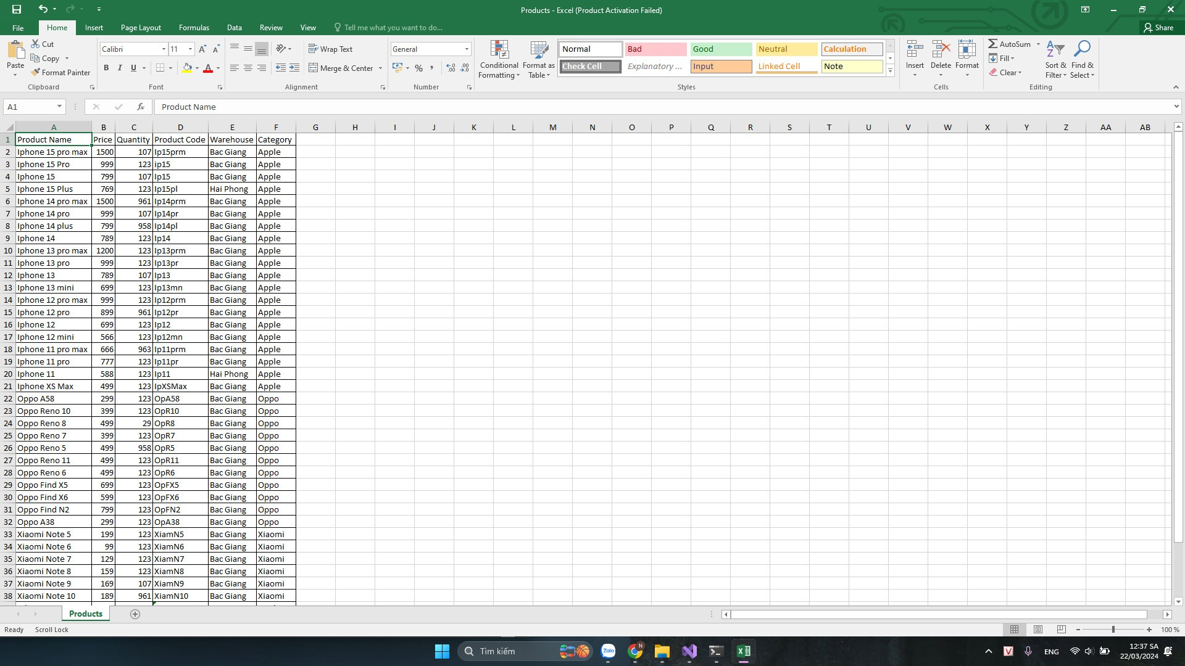

* **Creating a New Product:** Click the “Create new” button at the top of the page to create a new product. This will take you to a new page or pop-up window where you can enter the product’s details.



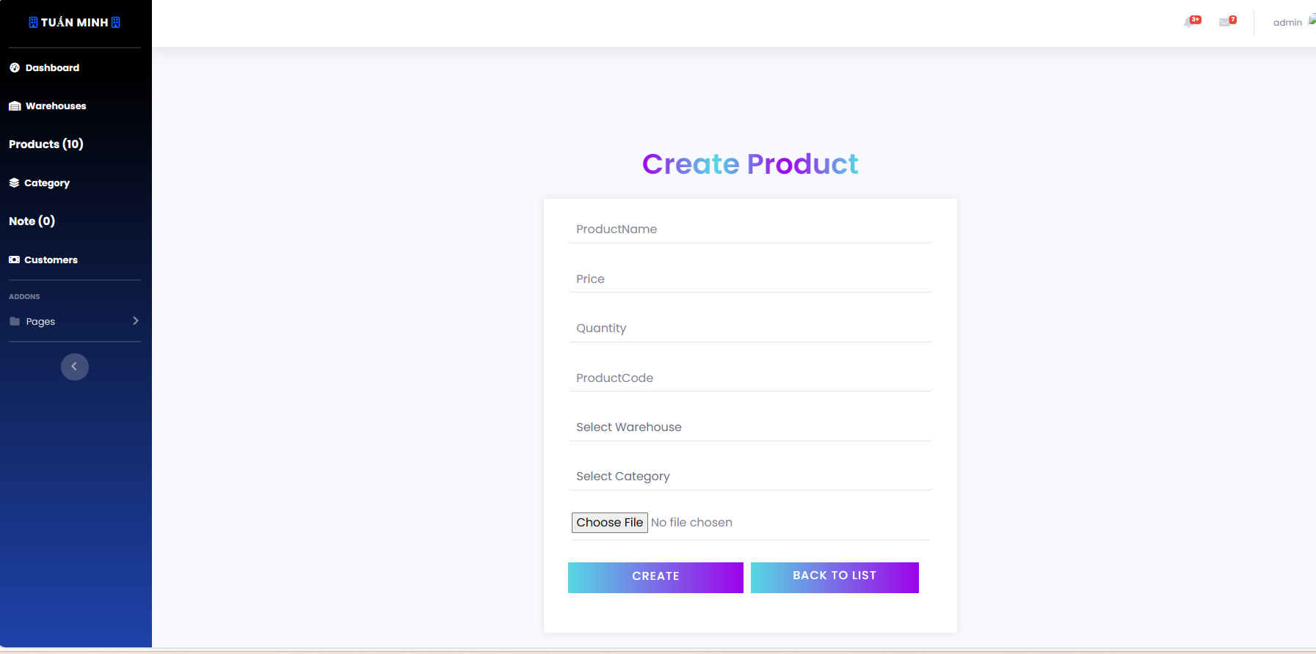

## **3. Workflow warehouse**

* **Viewing Warehouse Information**: The main part of the page shows a table of warehouses. Each row represents a warehouse and includes its name and address. You can view the information of each warehouse directly from this table.

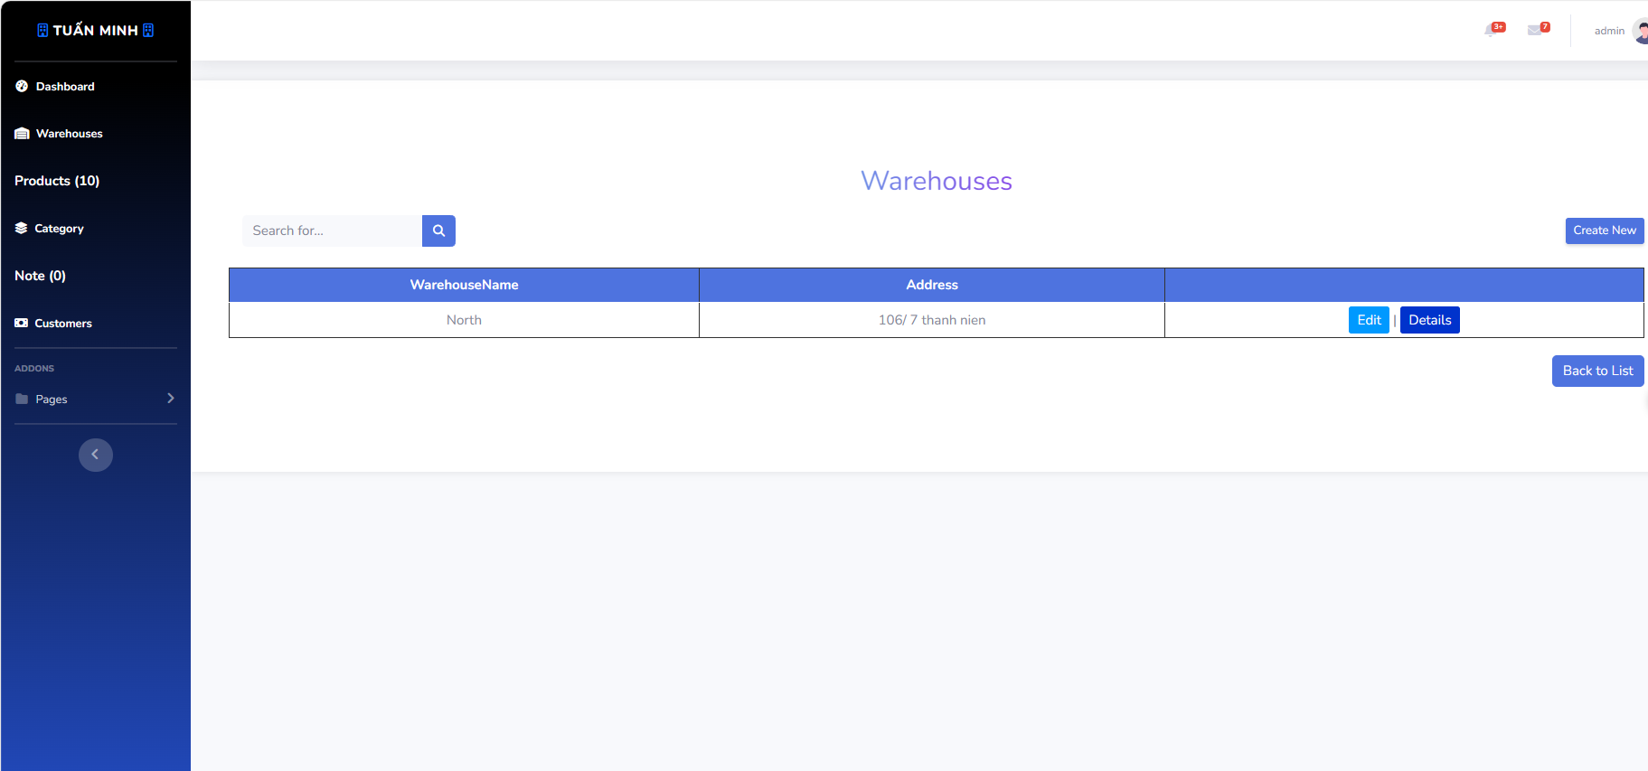

* **Searching for a Warehouse**: Use the search bar at the top of the page to search for a specific warehouse. Enter the warehouse name or any other relevant information and press Enter to display the search results in the table.

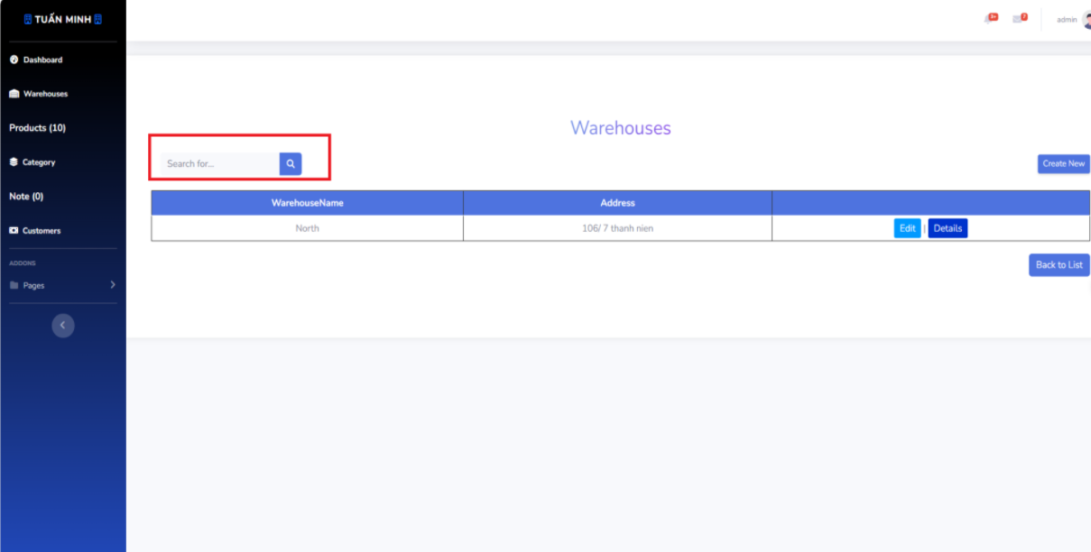

* **Creating a New Warehouse**: Click the “Create New” button at the top of the page to create a new warehouse. This will take you to a new page or pop-up window where you can enter the warehouse’s details.

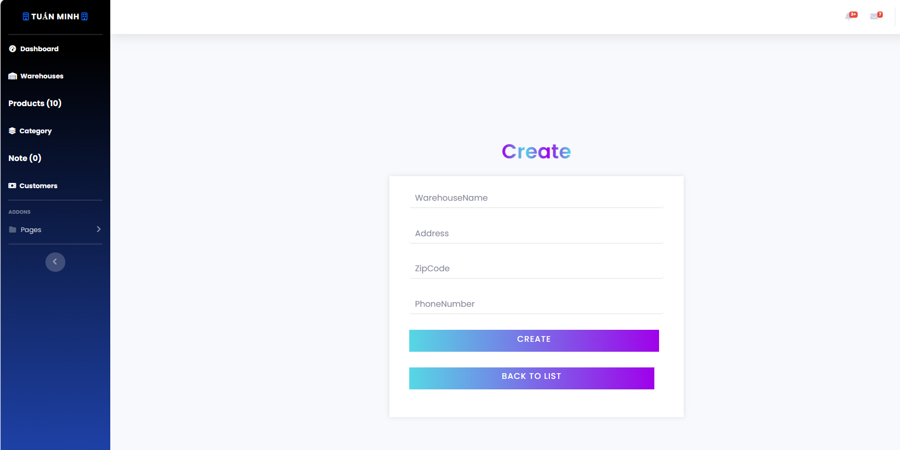

* **Editing a Warehouse**: To edit the information of a warehouse, locate the warehouse in the table and click the “Edit” button in its row. This will take you to a new page or pop-up window where you can modify the warehouse’s details.

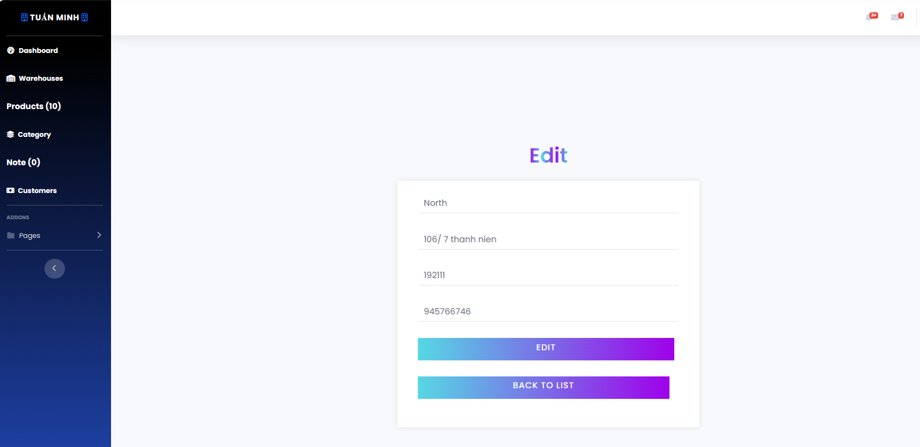

* **Viewing Warehouse Details**: To view more details about a warehouse, click the “Details” button in the row of the warehouse. This will take you to a new page or pop-up window that displays more detailed information about the warehouse, such as its full address and list of products.

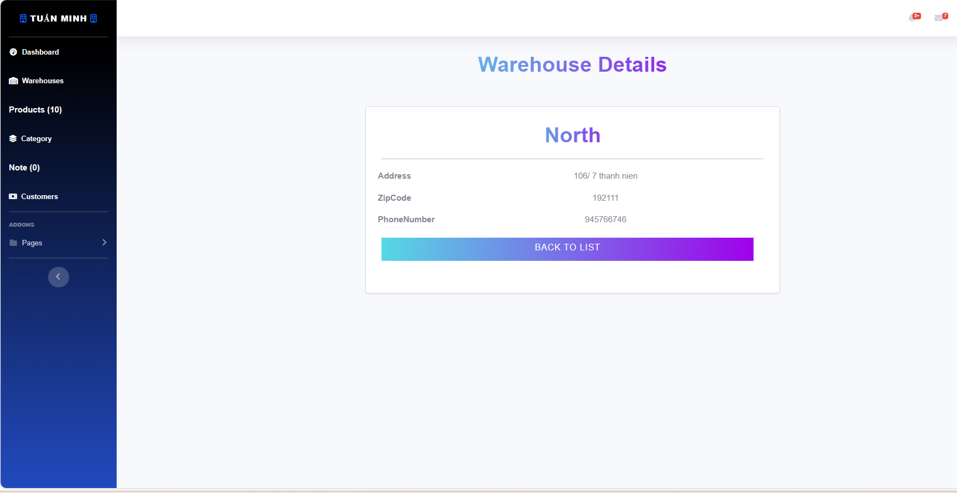

## **4. Workflow Category**

* **Viewing Category Information**: The main part of the page shows a table of categories. Each row represents a category and includes its name. You can view the information of each category directly from this table.

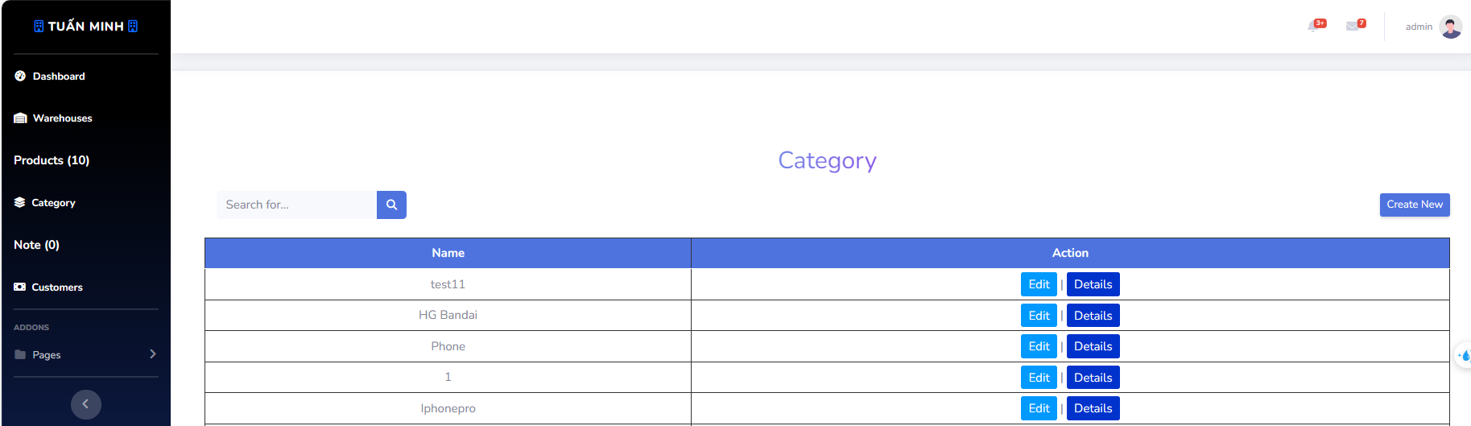

* **Searching for a Category**: Use the search bar at the top of the page to search for a specific category. Enter the category name or any other relevant information and press Enter to display the search results in the table.

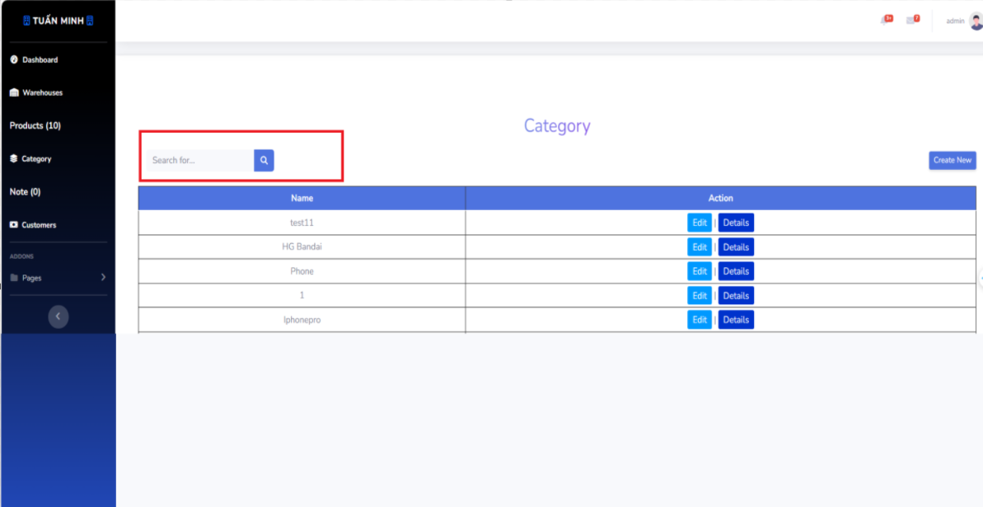

* **Creating a New Category**: Click the “Create New” button at the top of the page to create a new category. This will take you to a new page or pop-up window where you can enter the category’s details.

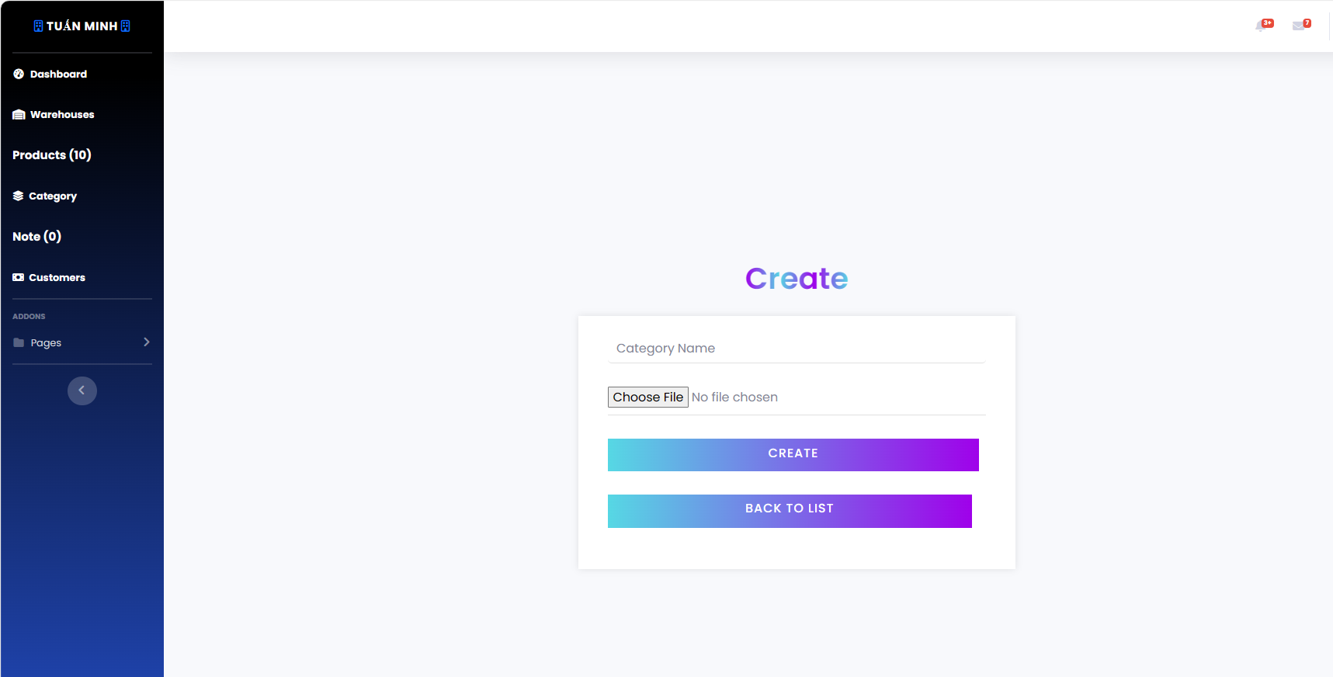

* **Editing a Category**: To edit the information of a category, locate the category in the table and click the “Edit” button in its row. This will take you to a new page or pop-up window where you can modify the category’s details.

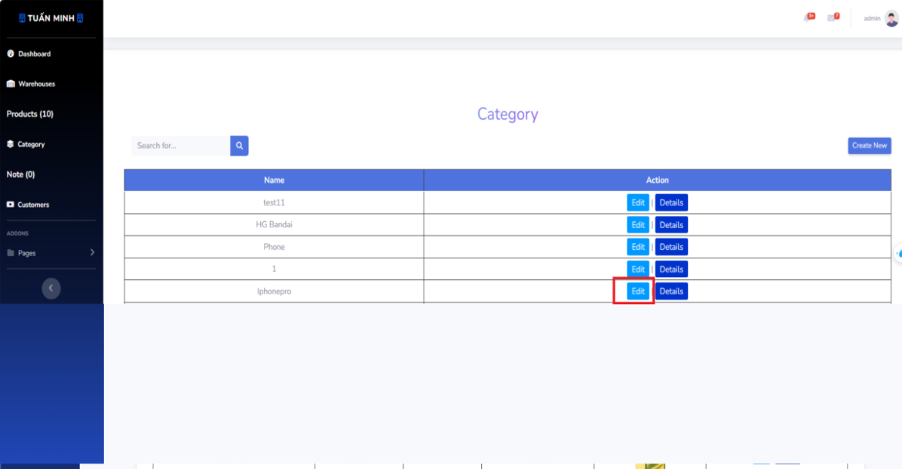

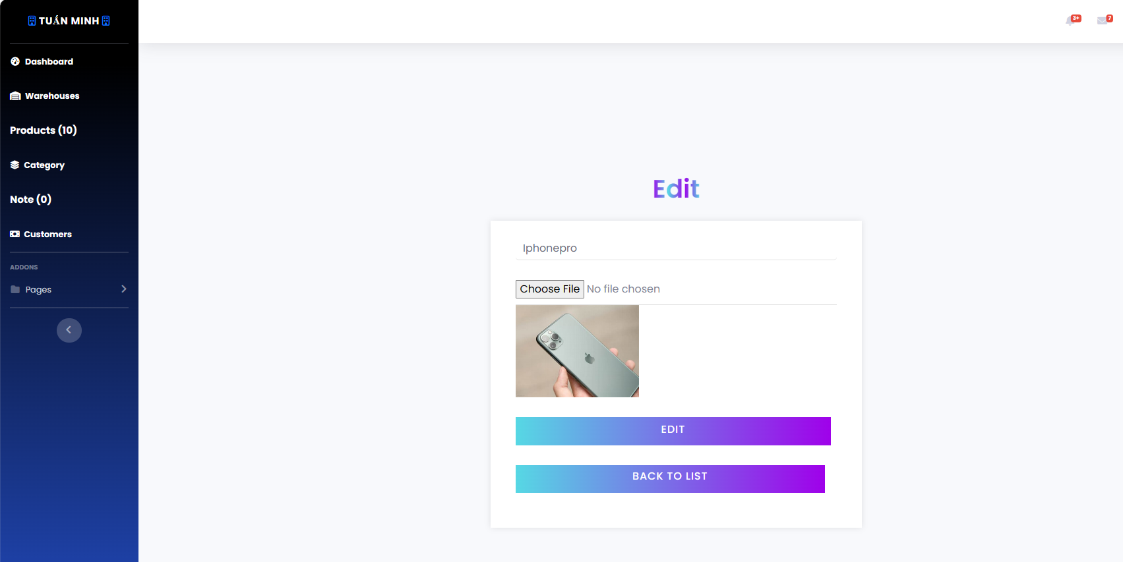

* **Viewing Category Details**: To view more details about a category, click the “Details” button in the row of the category. This will take you to a new page or pop-up window that displays more detailed information about the category.

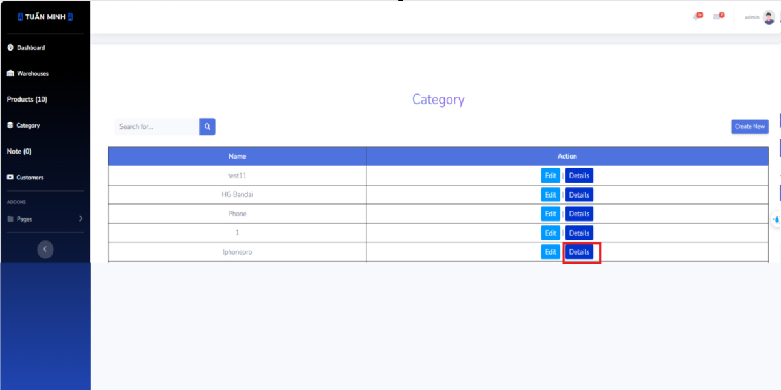

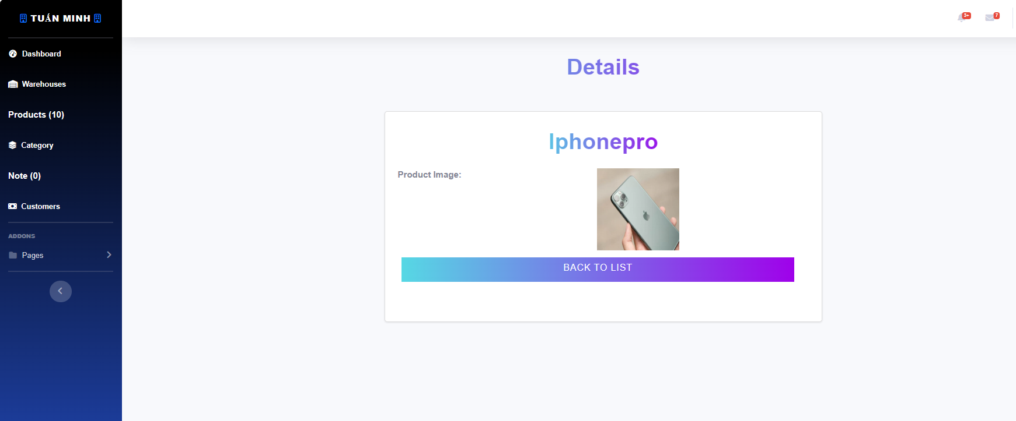

## **5. Workflow Customer**

* **Viewing Customer Information**: The main part of the page shows a table of customers. Each row represents a customer and includes its name and phone number. You can view the information of each customer directly from this table.

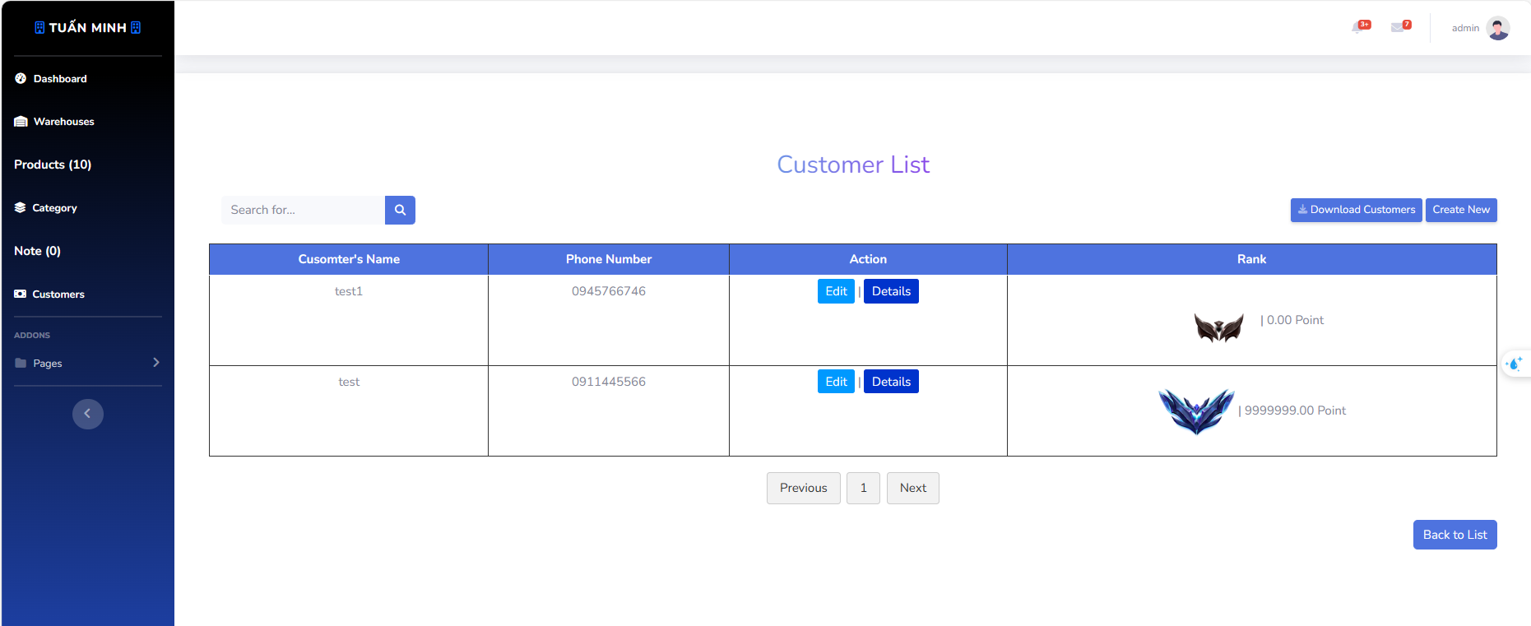

* **Searching for a Customer**: Use the search bar at the top of the page to search for a specific customer. Enter the customer name or any other relevant information and press Enter to display the search results in the table.

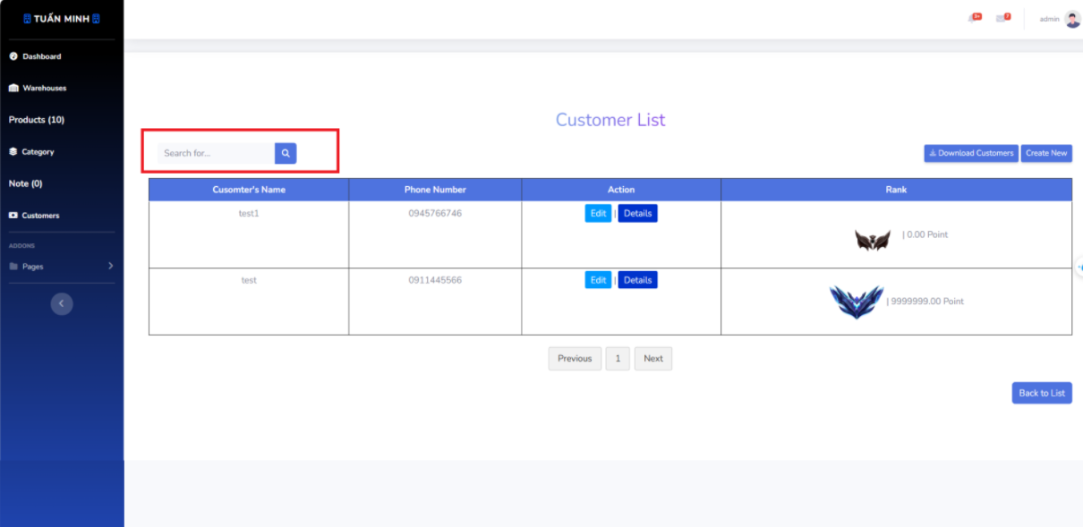

* **Creating a New Customer**: Click the “Create New” button at the top of the page to create a new customer. This will take you to a new page or pop-up window where you can enter the customer’s details.

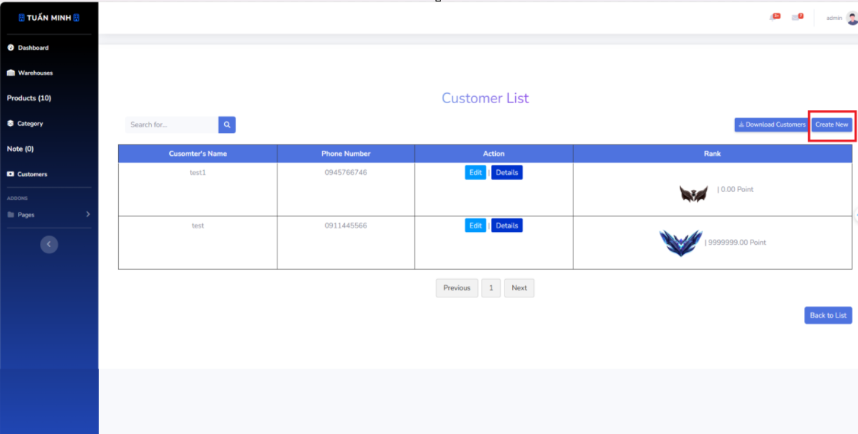

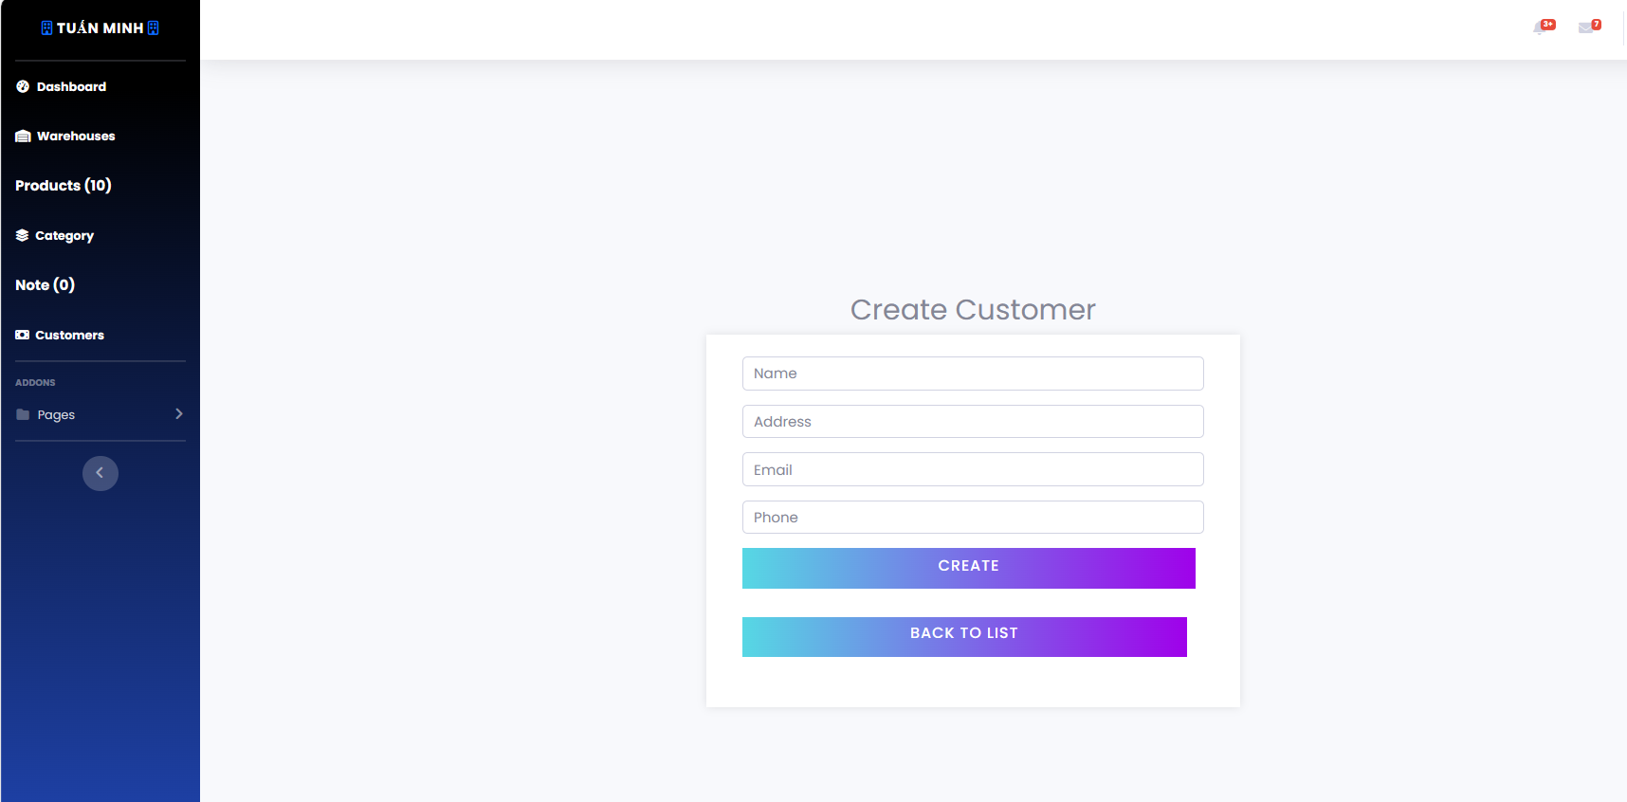

* **Editing a Customer**: To edit the information of a customer, locate the customer in the table and click the “Edit” button in its row. This will take you to a new page or pop-up window where you can modify the customer’s details.

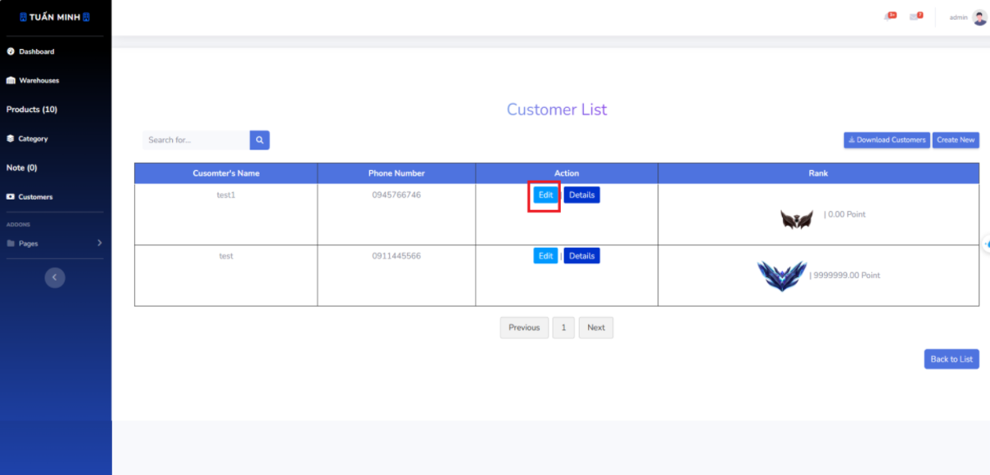

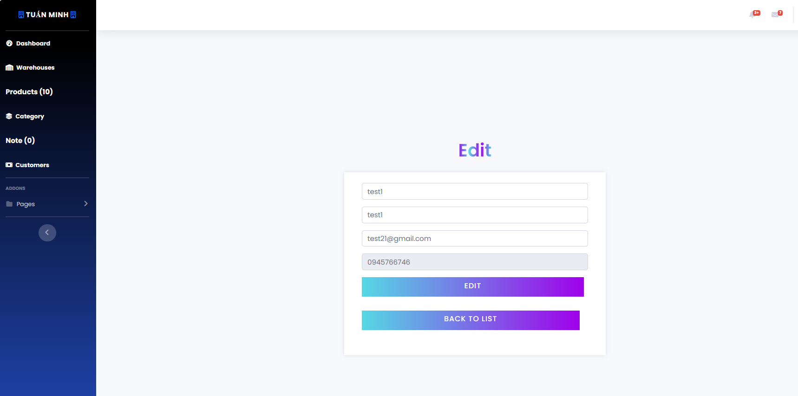

* **Viewing Customer Details**: To view more details about a customer, click the “Details” button in the row of the customer. This will take you to a new page or pop-up window that displays more detailed information about the customer.

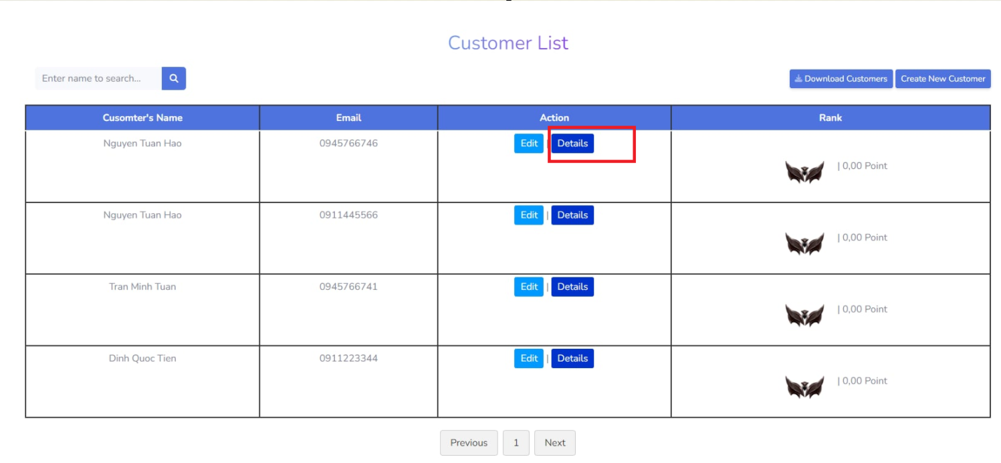

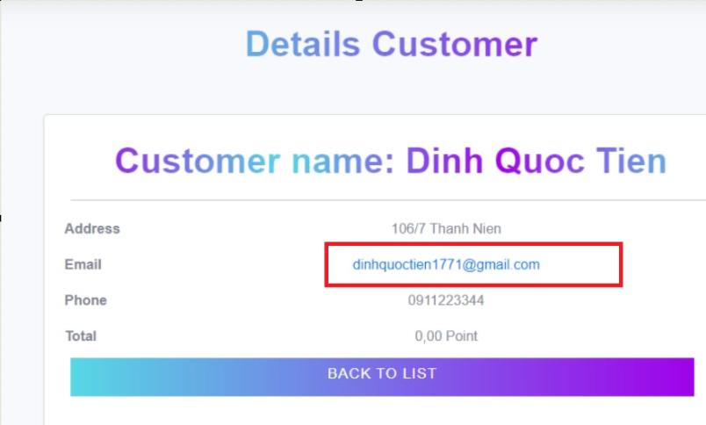

When we click on the customer's gmail on the customer's details page, we can send the customer's gmail. it will go to gmail sending page. Enter content and send.

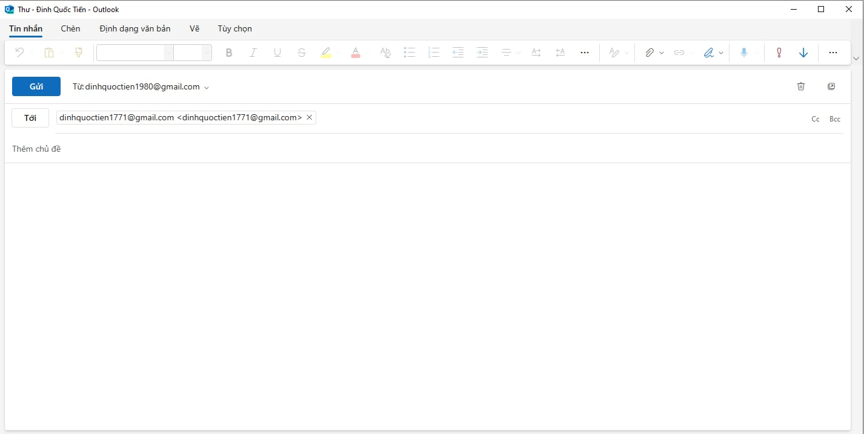

* **Downloading Customer Information**: Click the “Download Customer” button at the top of the page to download the detailed information of all customers as an Excel file.

## **6. Workflow Note Keeper**

* **Viewing Note Information**: The main part of the page shows a table of notes. Each row represents a note and includes its code, status, and action buttons.

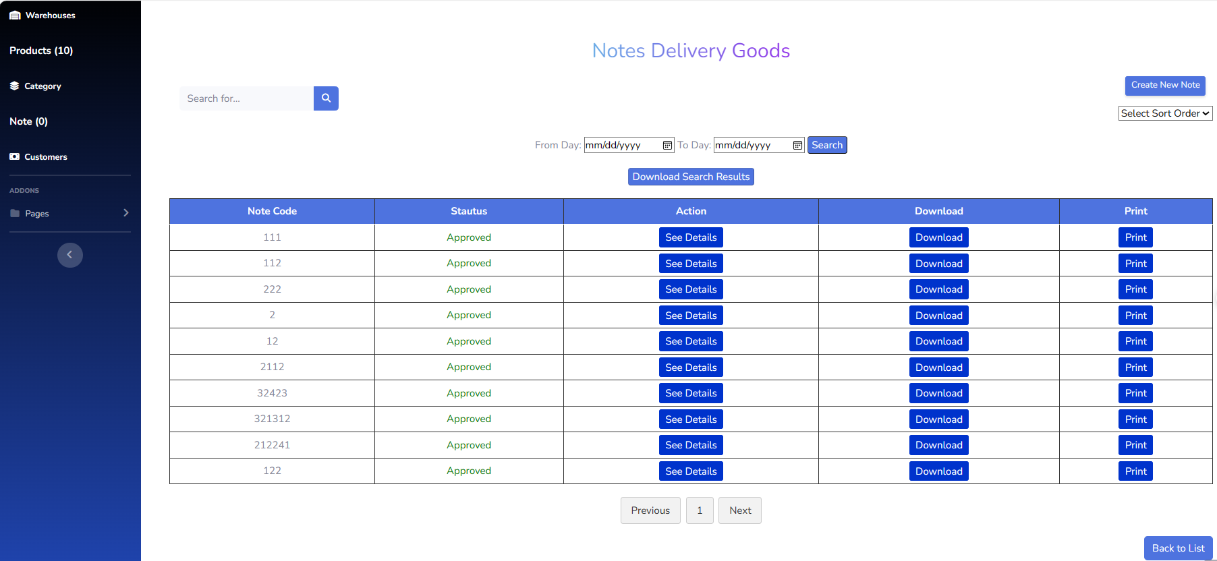

* **Searching for a Note**: Use the search bar at the top of the page to search for a specific note. Enter the note code or any other relevant information and press Enter to display the search results in the table.

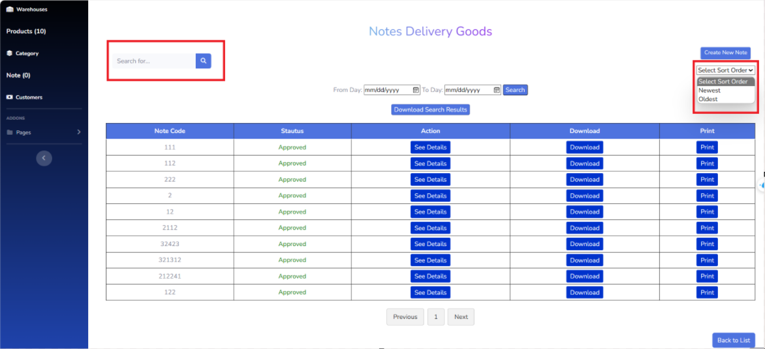

* **Searching by Day**: Use the “From Day” and “To Day” fields at the top of the page to filter notes by a specific date range. After entering the desired dates, click the “Search” button to update the table with the search results. You can download the notes after searching to an excel file

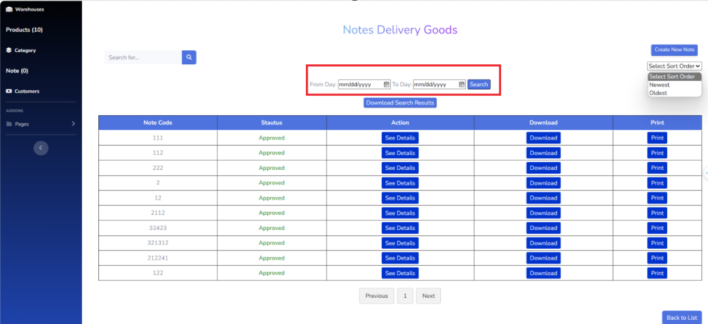

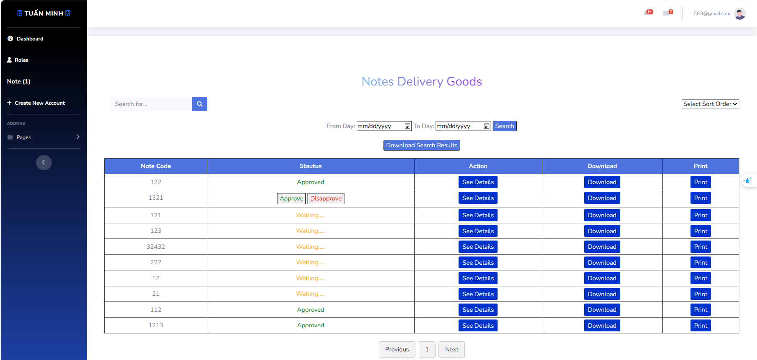

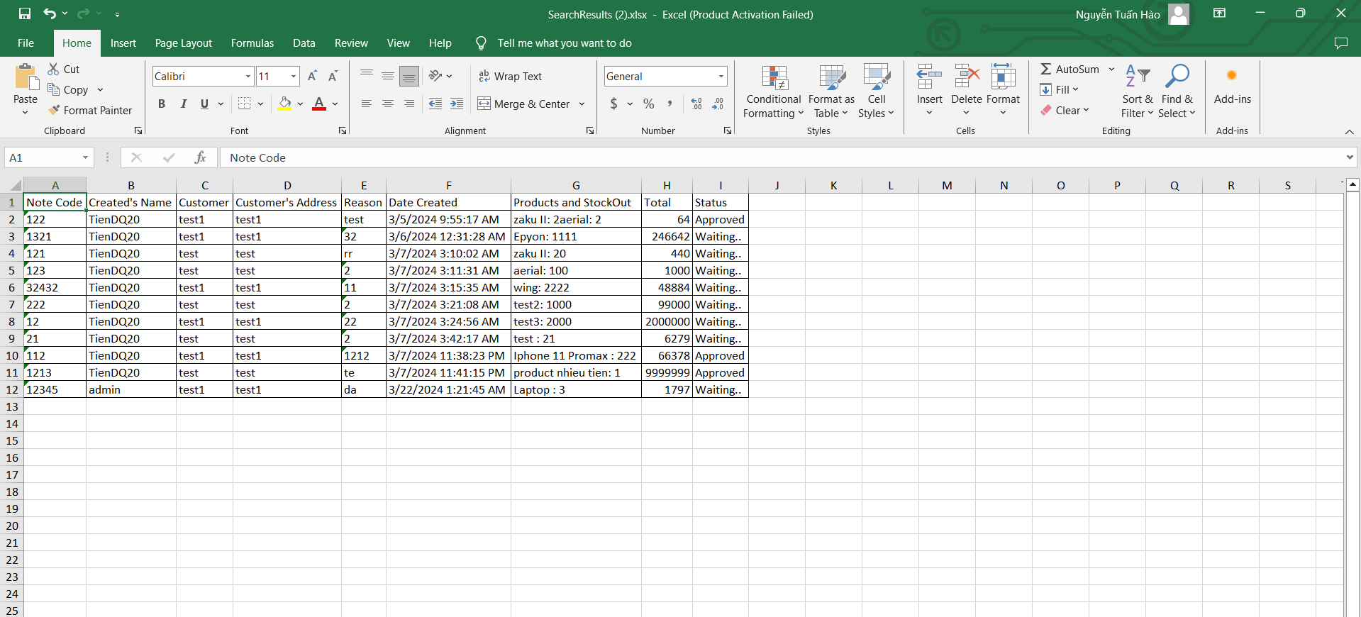

* **Creating a New Note**: Click the “Create New Note” button at the top of the page to create a new note. This will take you to a new page or pop-up window where you can enter the note’s details.

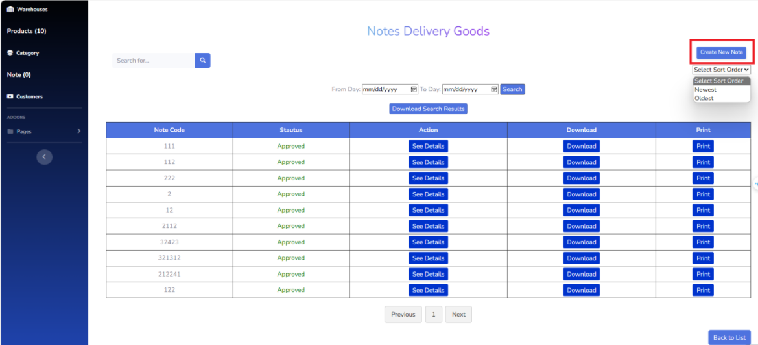

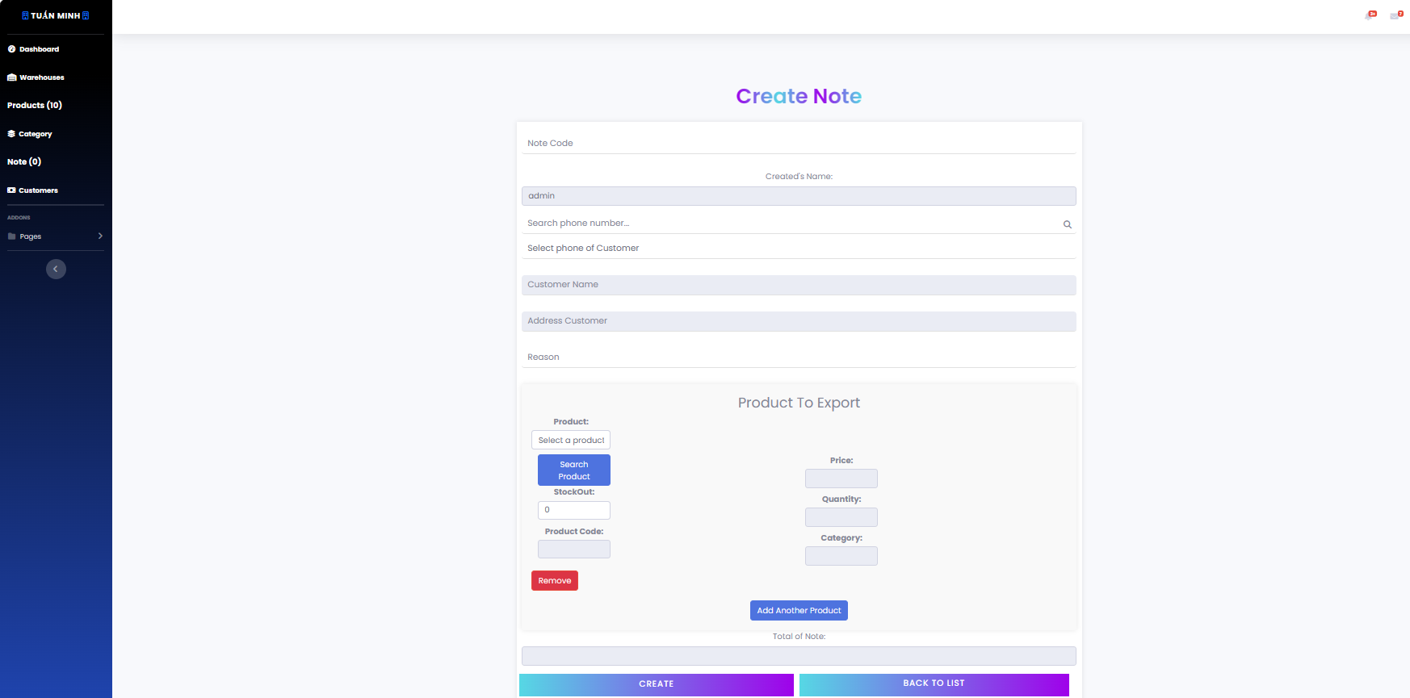

* **Viewing Note Details**: To view more details about a note, click the “See Details” button in the row of the note. This will take you to a new page or pop-up window that displays more detailed information about the note.

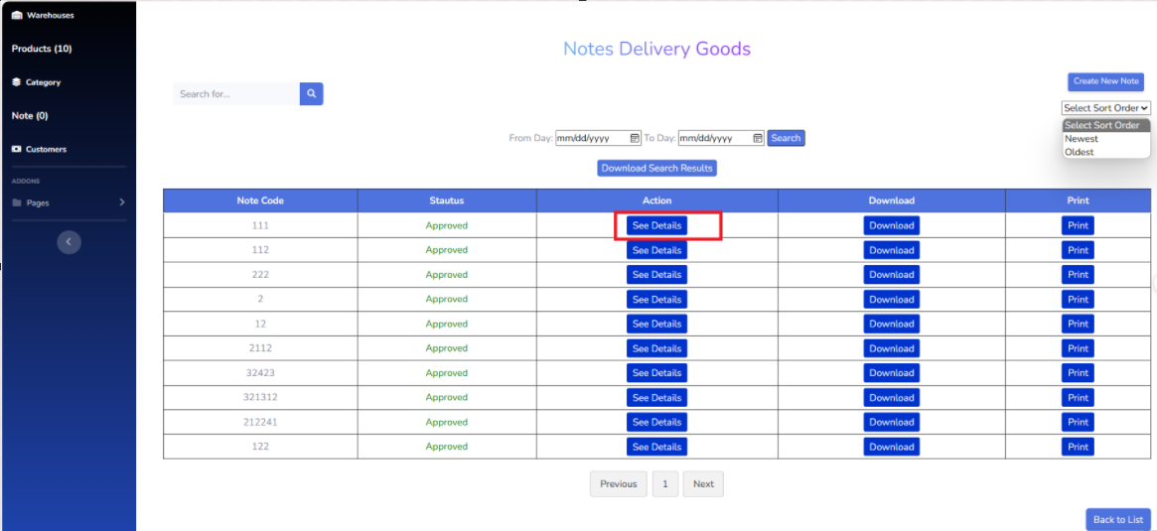

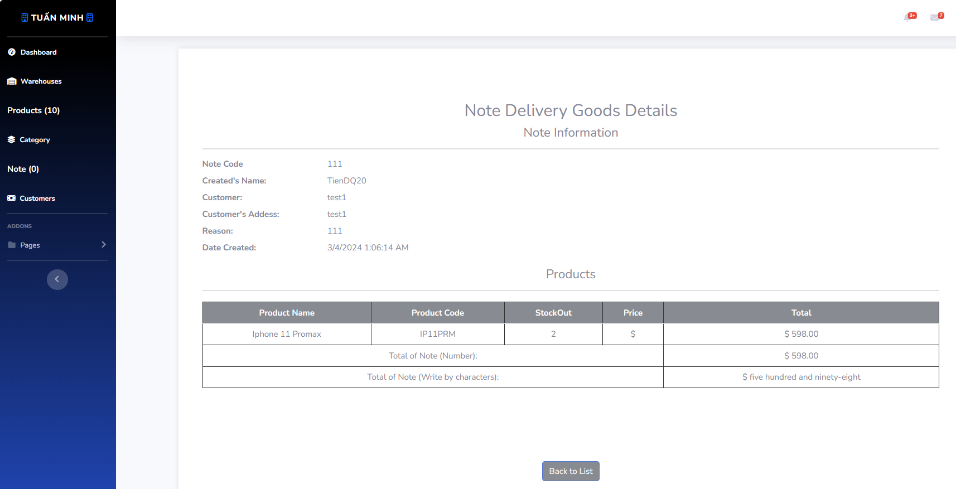

* **Downloading a Note**: To download the information of a note, click the “Download” button in the row of the note. The note’s information will be downloaded as a file to your device.

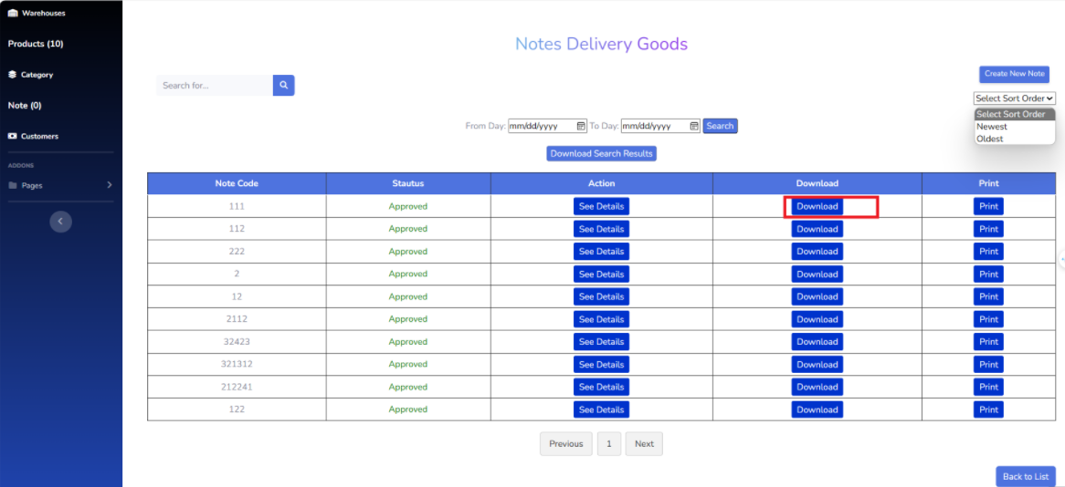

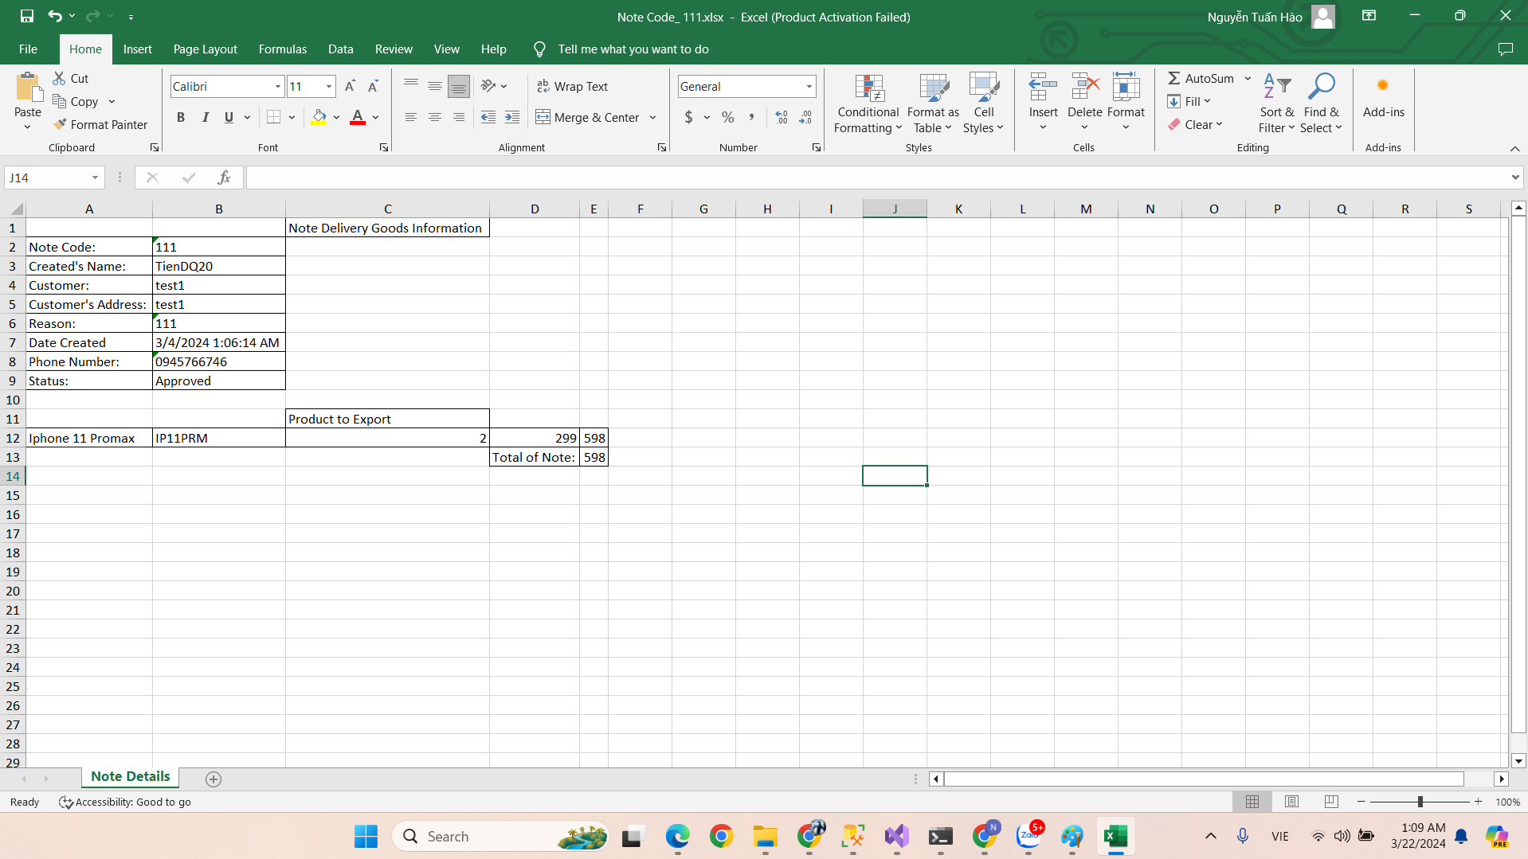

* **Printing a Note**: To print the information of a note, click the “Print” button in the row of the note. This will open a print dialog where you can select your printing options and print the note’s information.

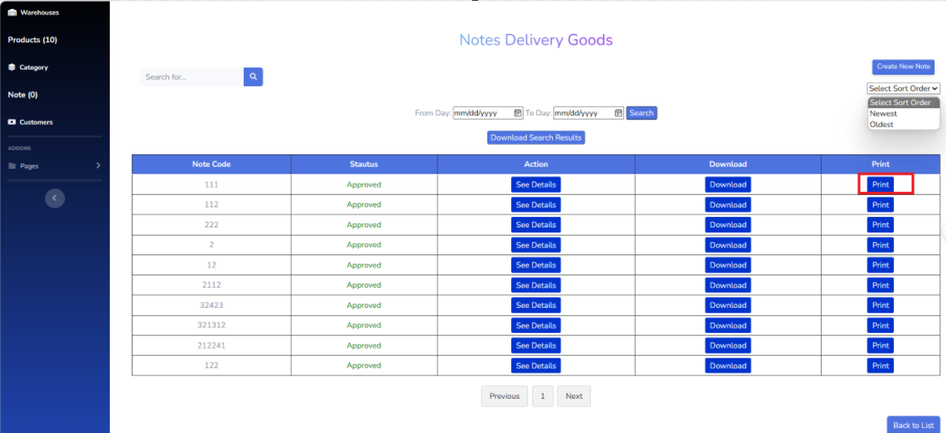

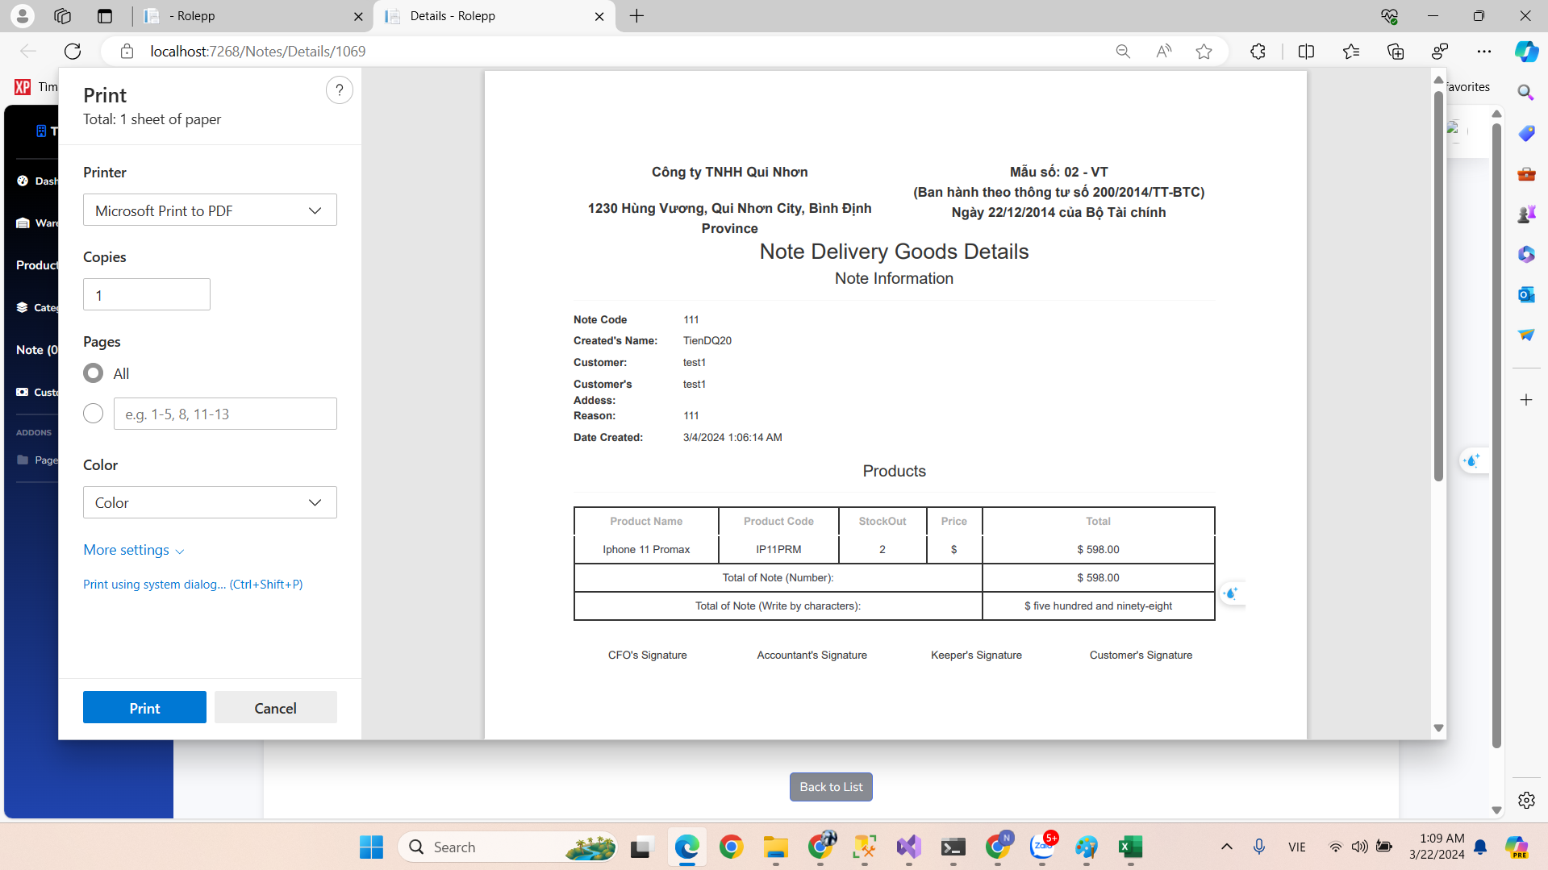

* **Downloading Search Results**: Click the “Download Search Results” button at the top of the page to download the information of all notes displayed in the table as an Excel file. You can download the notes after searching to an excel file.

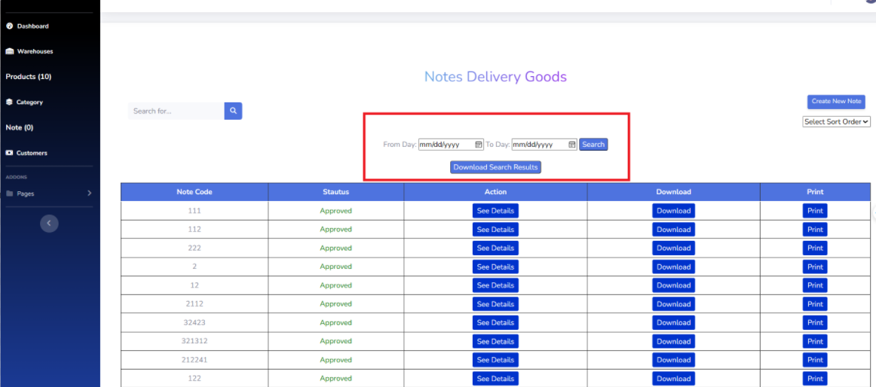

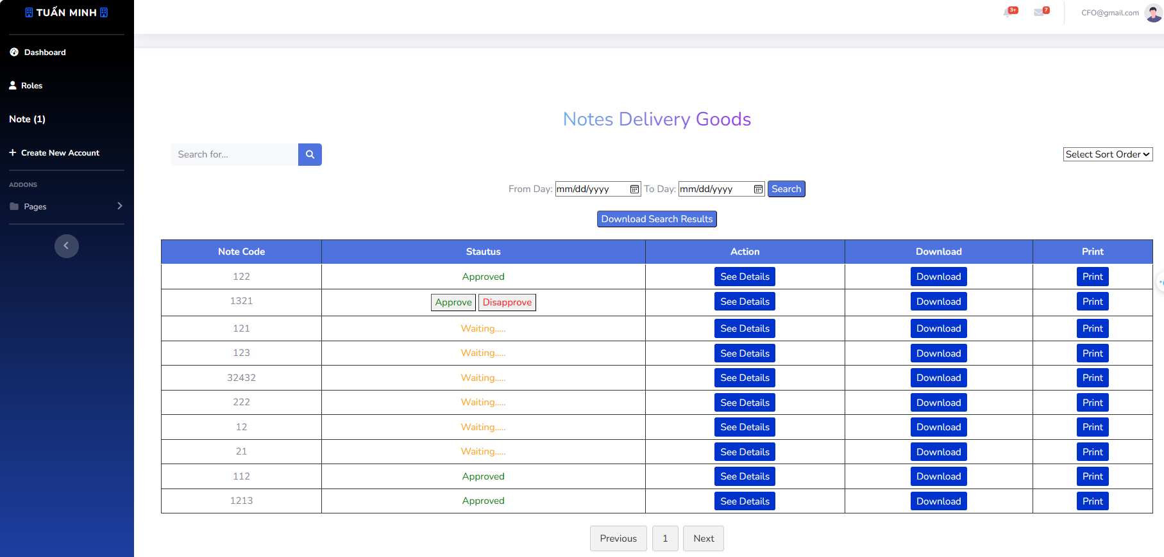

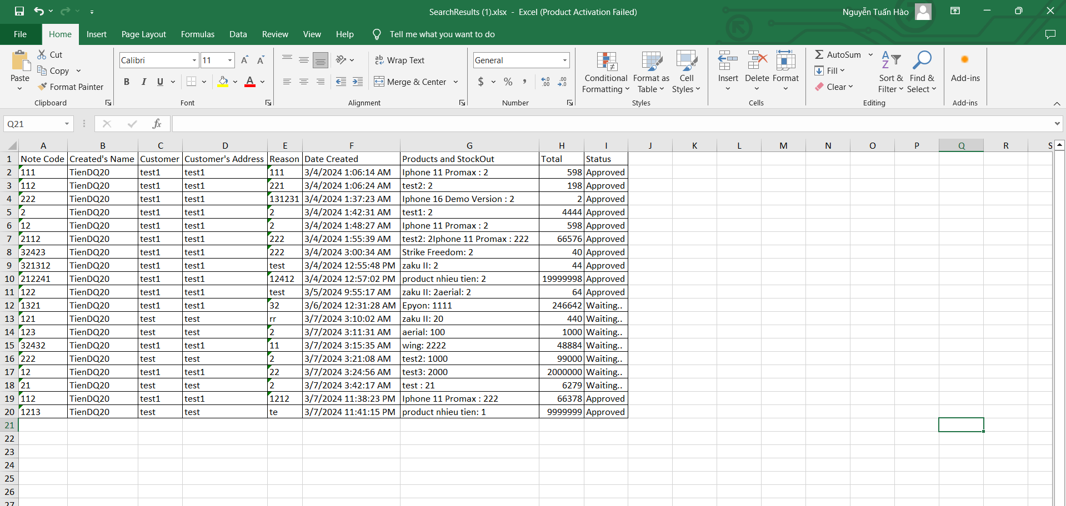

## **7. Workflow Note accountant**

* **Viewing Note Information**: The main part of the page shows a table of notes. Each row represents a note and includes its code, status, and action buttons.

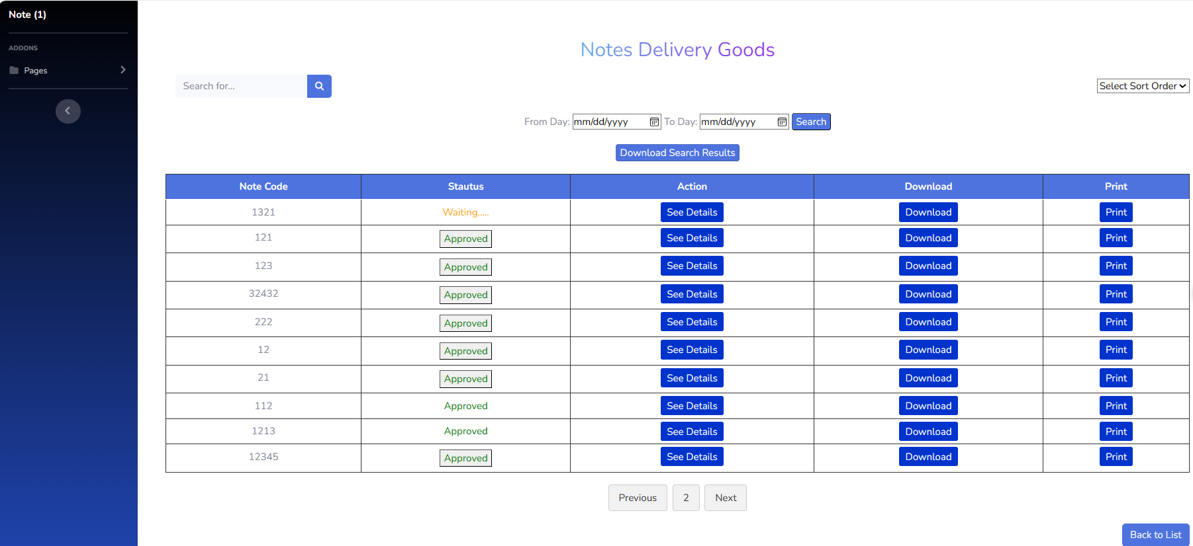

* **Searching for Note**: Use the search bar at the top of the page to search for a specific note. Enter the note code or any other relevant information and press Enter to display the search results in the table.

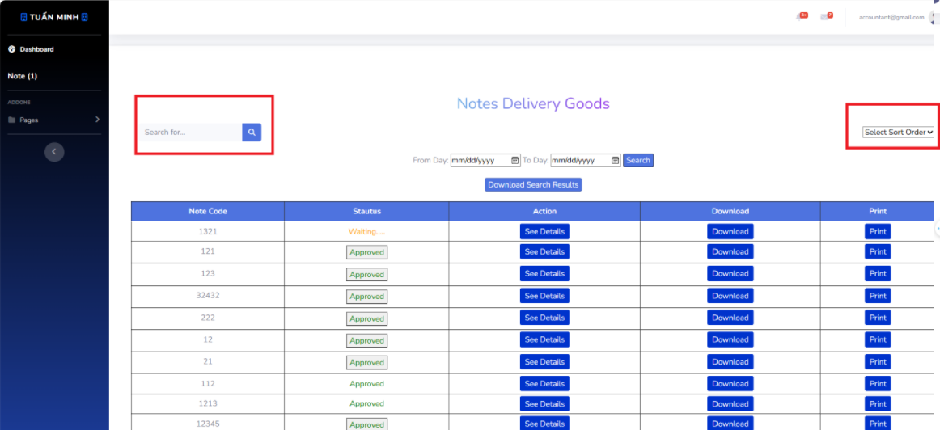

* **Searching by Day**: Use the “From Day” and “To Day” fields at the top of the page to filter notes by a specific date range. After entering the desired dates, click the “Search” button to update the table with the search results.

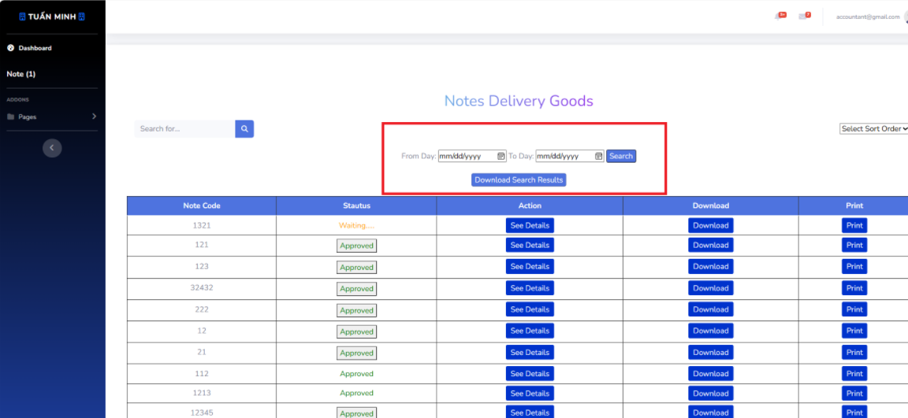

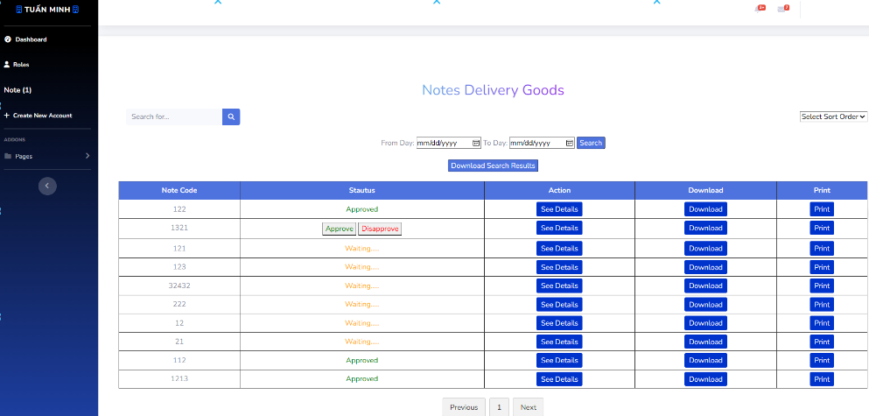



* **Viewing Note Details**: To view more details about a note, click the “See Details” button in the row of the note. This will take you to a new page or pop-up window that displays more detailed information about the note.

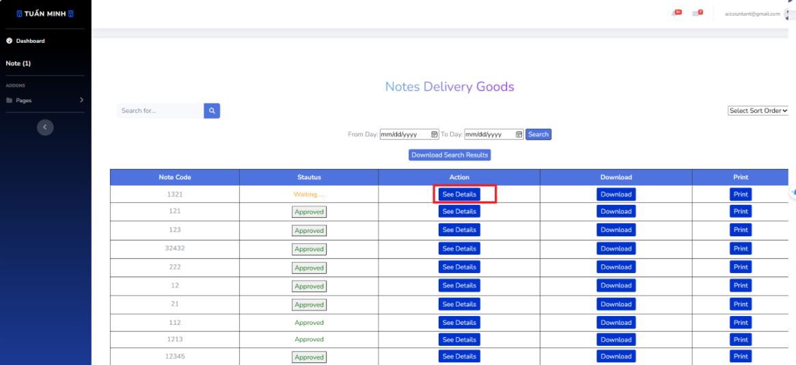

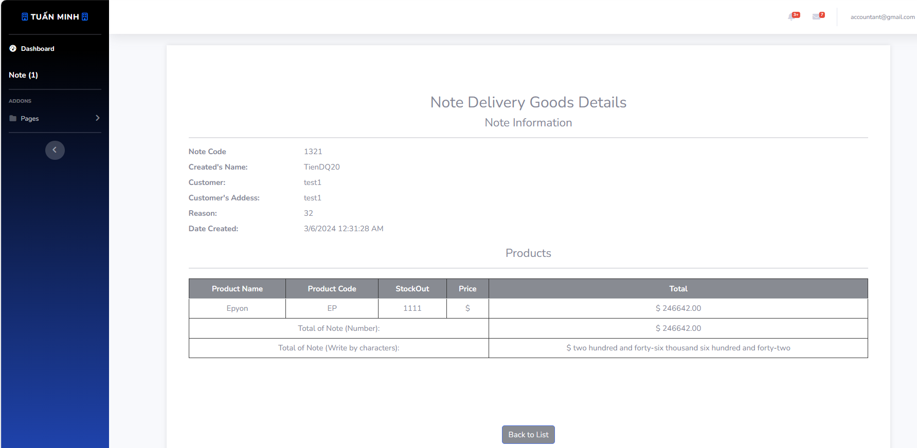

* **Downloading a Note**: To download the information of a note, click the “Download” button in the row of the note. The note’s information will be downloaded as a file to your device.

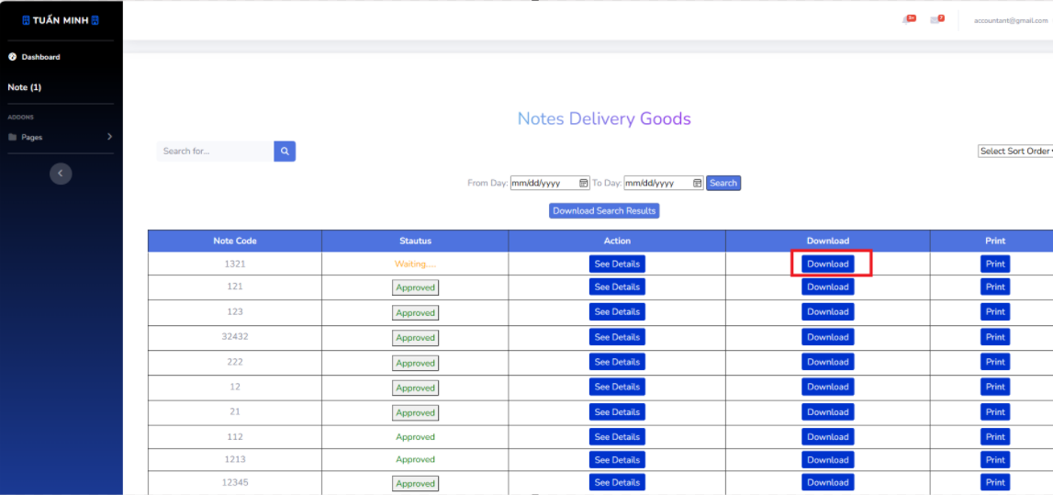

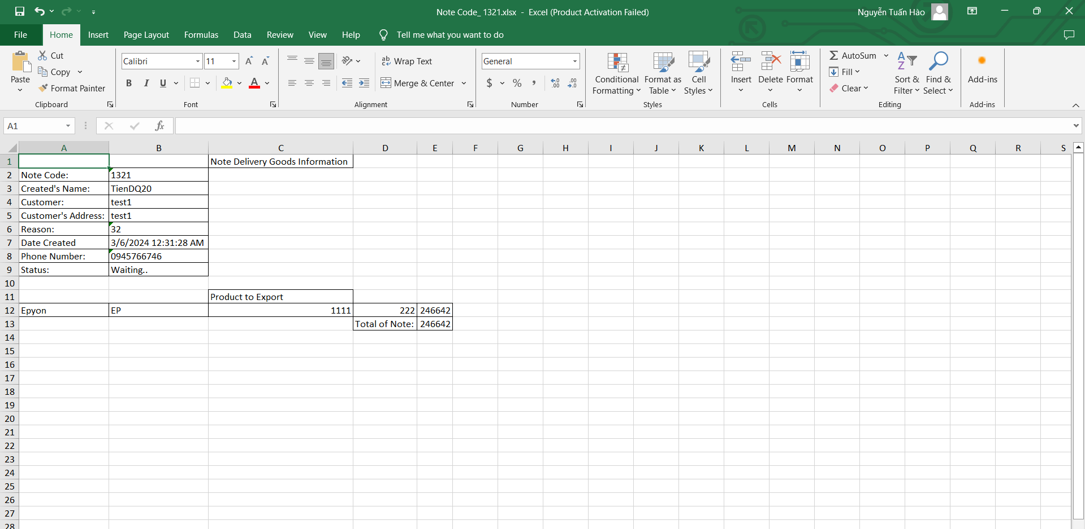

* **Printing a Note**: To print the information of a note, click the “Print” button in the row of the note. This will open a print dialog where you can select your printing options and print the note’s information.

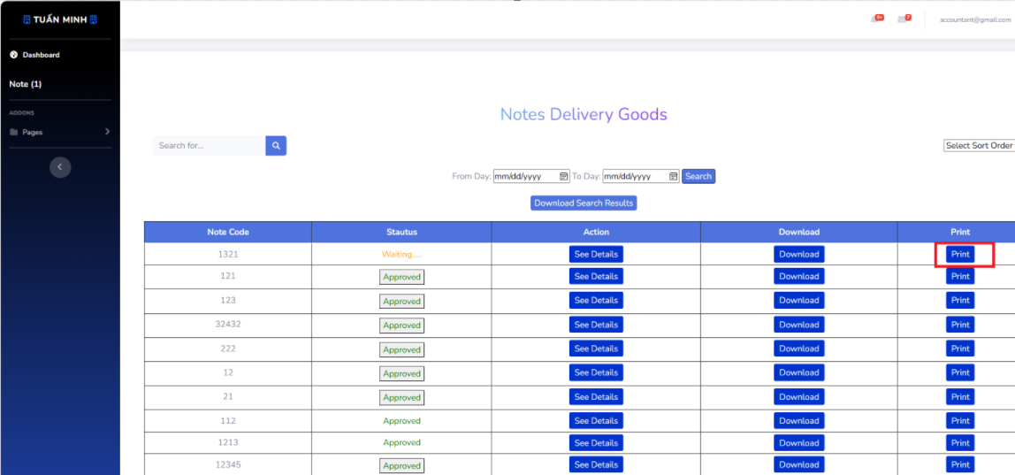

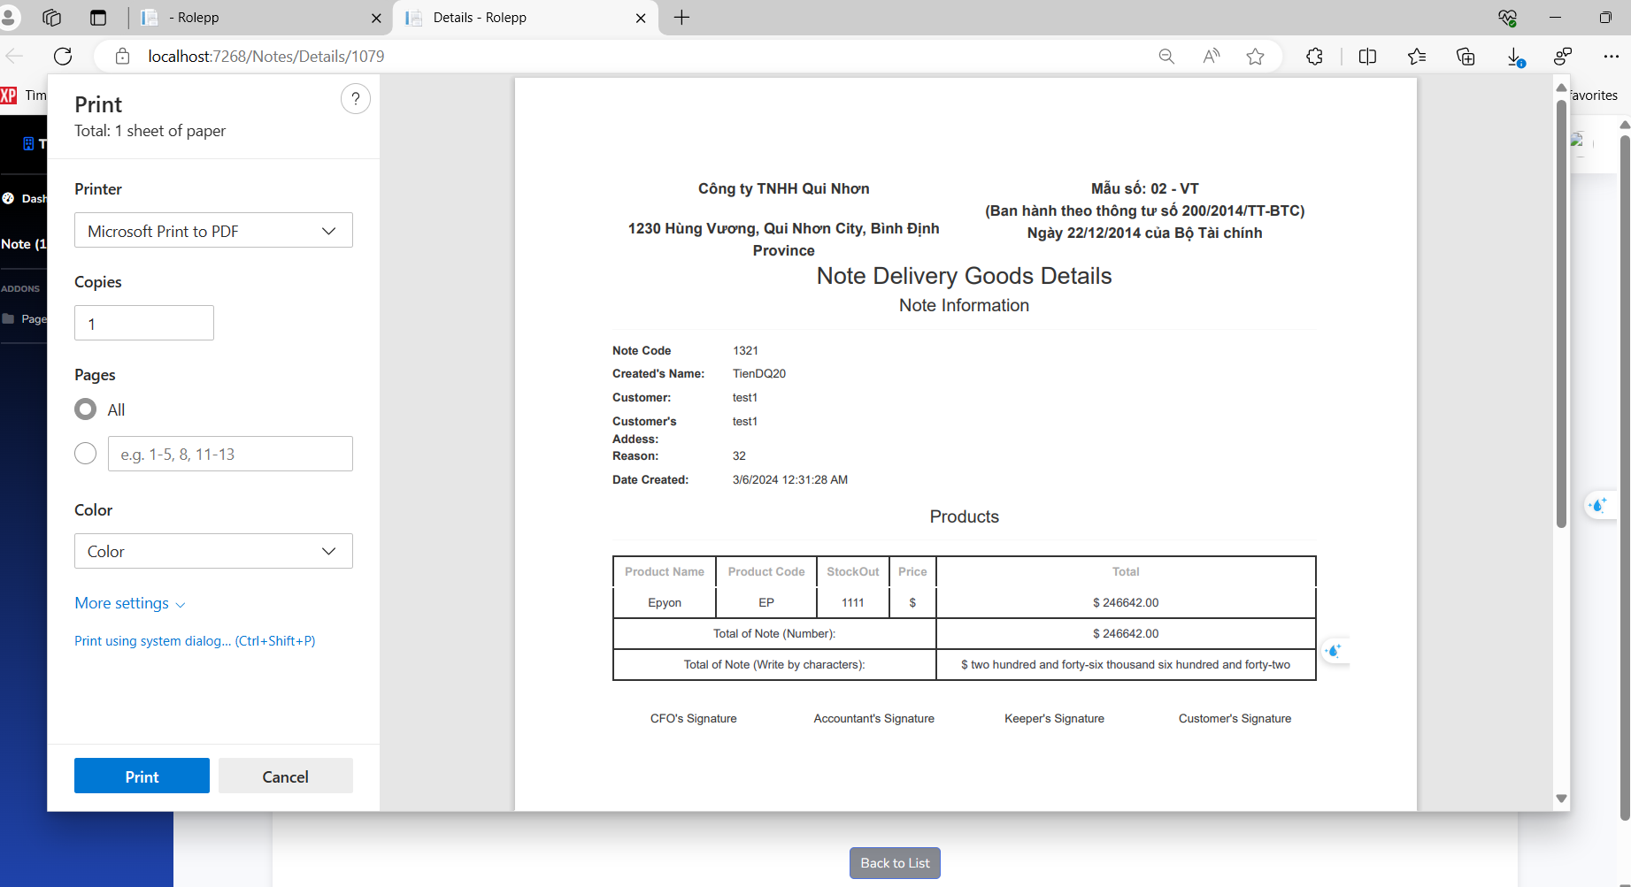

* **Note status**: As an accountant, you have the ability to approve notes created by the keeper or set them back to waiting. In the “Action” column of each note, there will be a button labeled “Approve”. If the note is currently waiting, clicking “Approve” will change the status of the note to “Approved”. If the note is currently approved, clicking “Approve” will change the status back to “Waiting”. This allows you to effectively manage the approval process of each note.

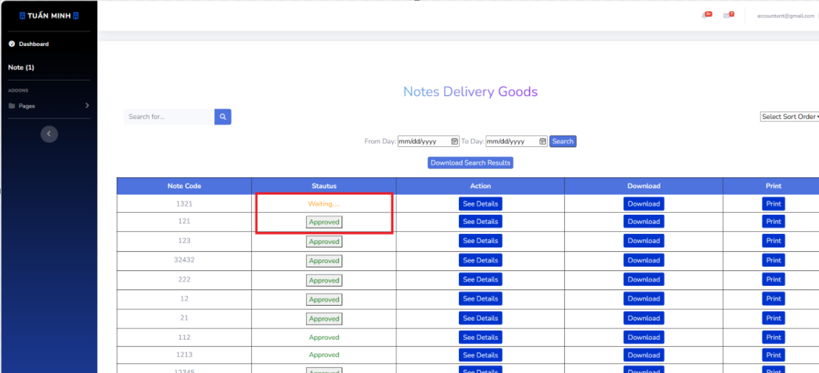

## **8. Workflow Note CFO**

* **Viewing Note Information**: The main part of the page shows a table of notes. Each row represents a note and includes its code, status, and action buttons.

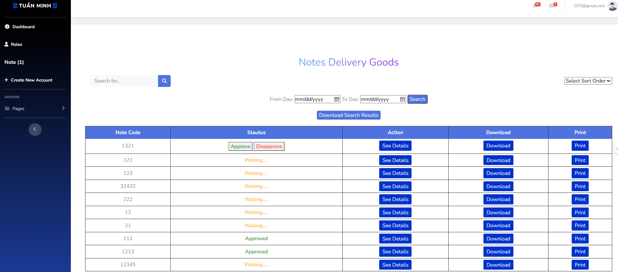

* **Searching for a Note**: Use the search bar at the top of the page to search for a specific note. Enter the note code or any other relevant information and press Enter to display the search results in the table.

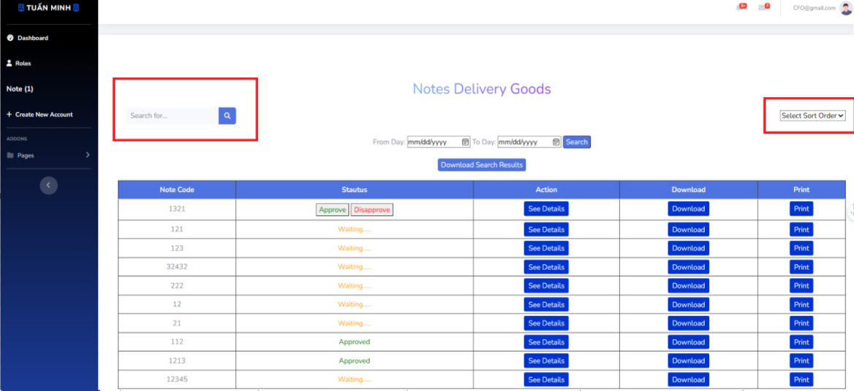

* **Searching by Day**: Use the “From Day” and “To Day” fields at the top of the page to filter notes by a specific date range. After entering the desired dates, click the “Search” button to update the table with the search results. You ca download the notes after searching to an excel file.

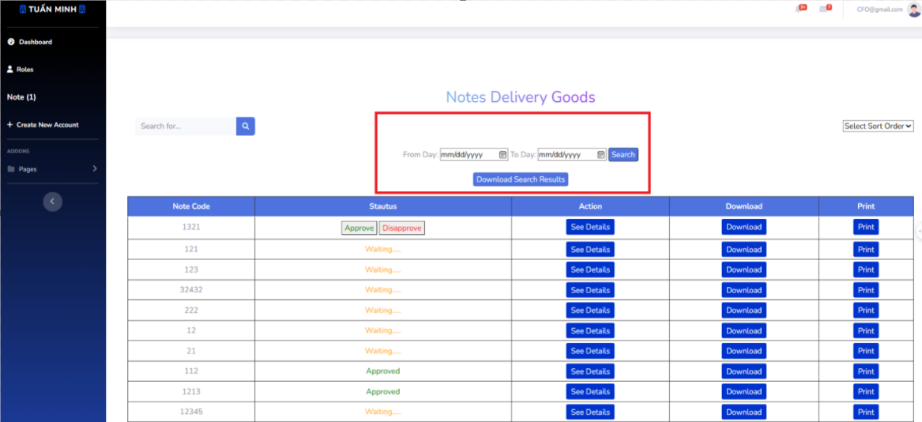





* **Viewing Note Details**: To view more details about a note, click the “See Details” button in the row of the note. This will take you to a new page or pop-up window that displays more detailed information about the note.

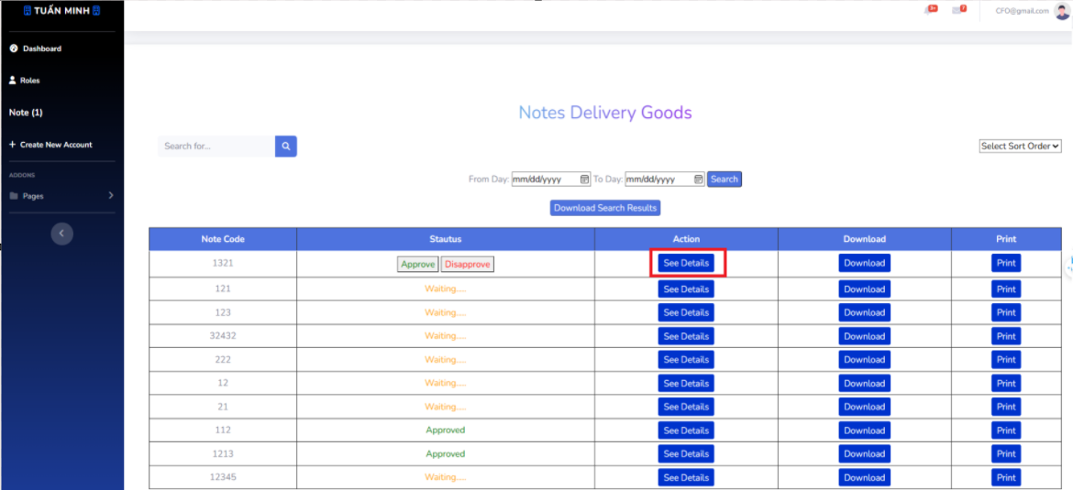

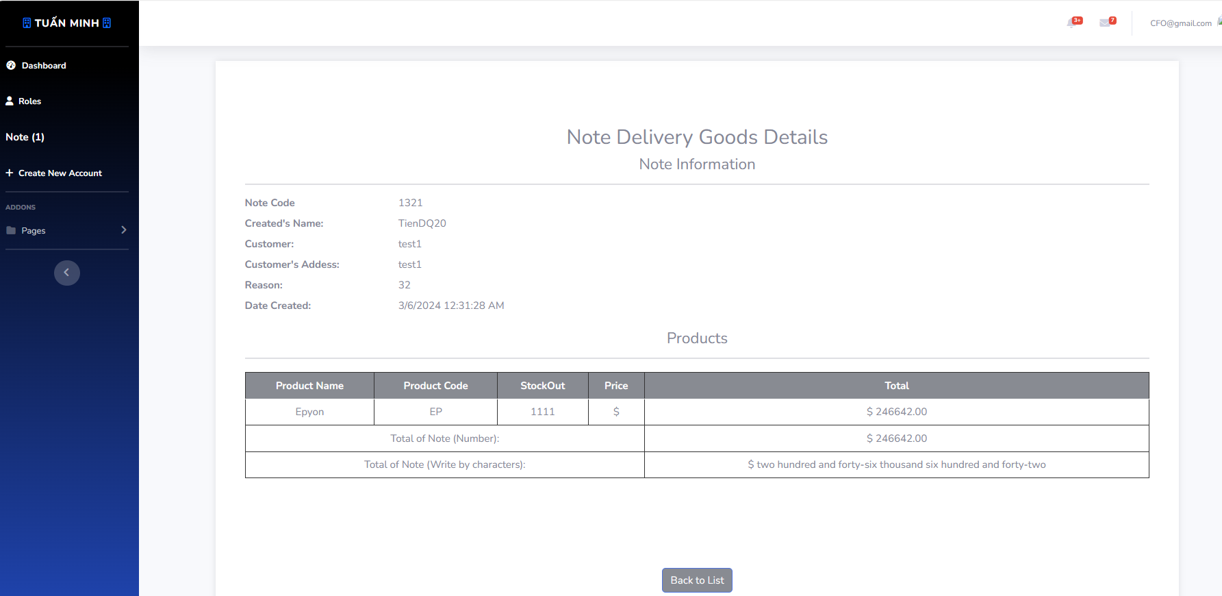

* **Downloading a Note**: To download the information of a note, click the “Download” button in the row of the note. The note’s information will be downloaded as a file to your device.

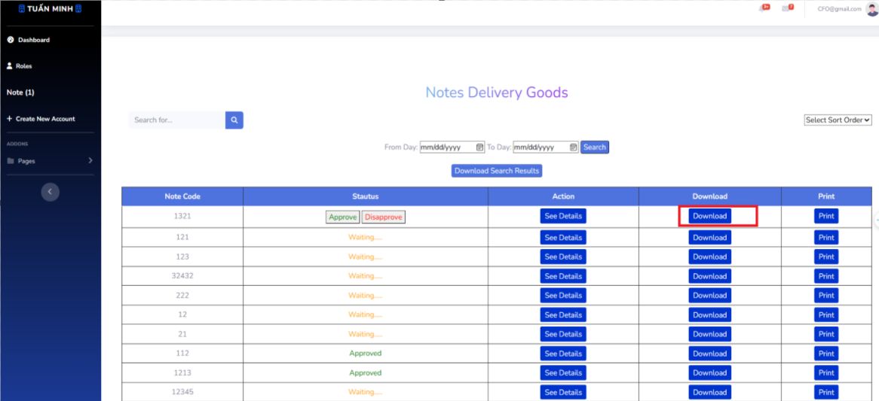

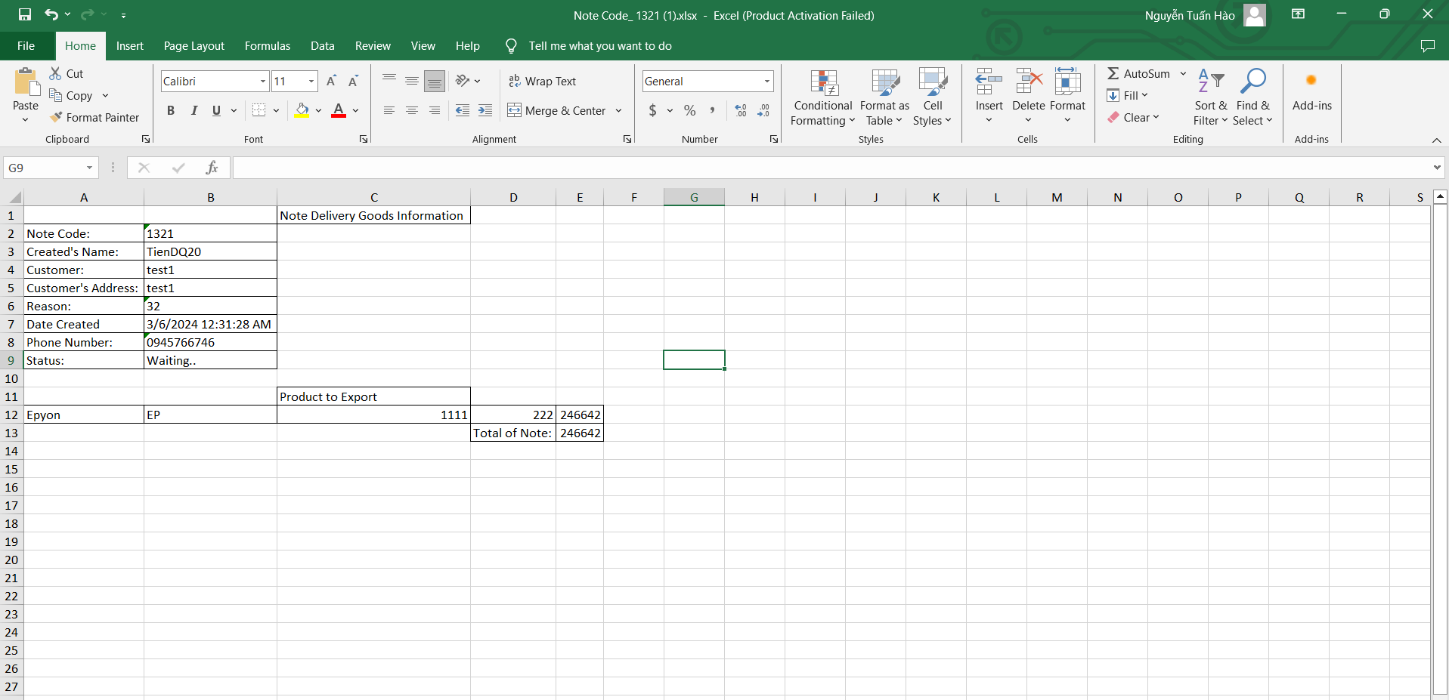

* **Printing a Note**: To print the information of a note, click the “Print” button in the row of the note. This will open a print dialog where you can select your printing options and print the note’s information.

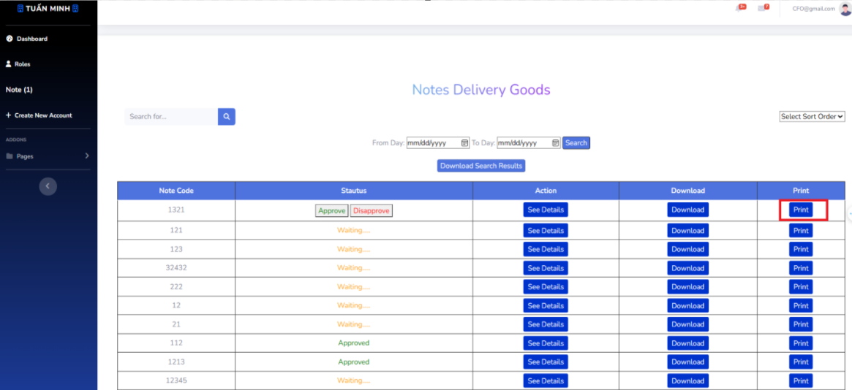

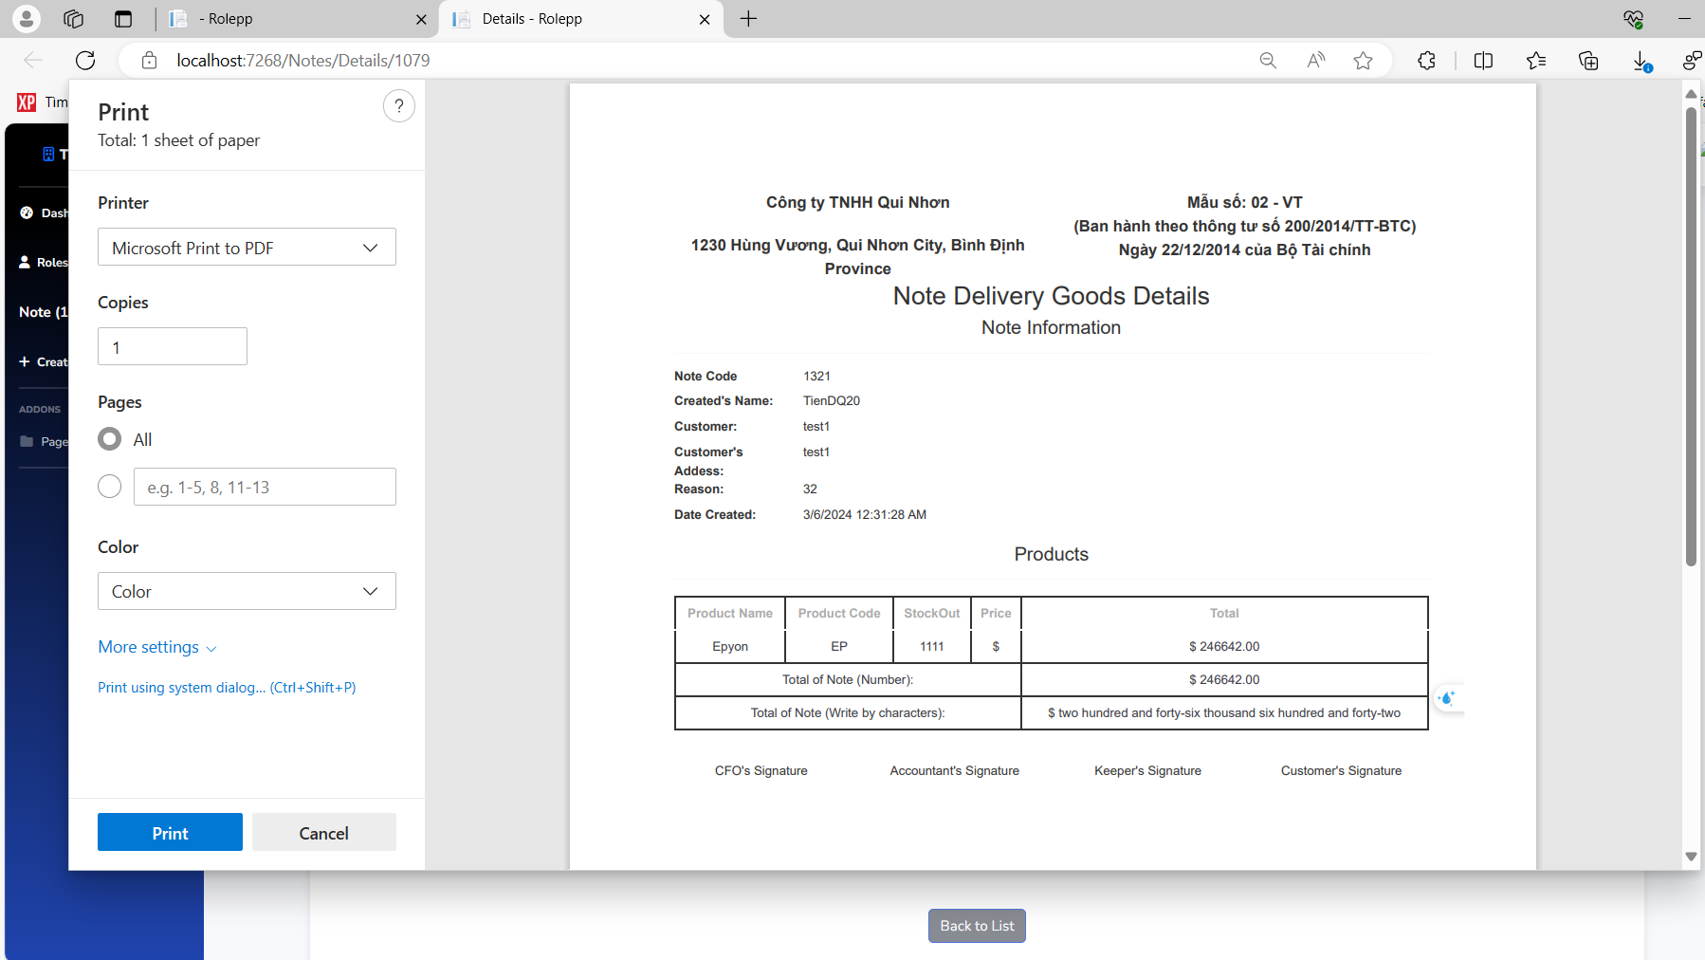

* **Approving or Unapproving a Note**: As a CFO, you have the ability to approve or reject notes sent by the accountant. In the “Action” column of each note, there will be buttons to “Approve” or “unapprove” the note. Clicking “Approve” will change the status of the note to “Approved”, and clicking “unapprove” will change the status to “unapproved”.

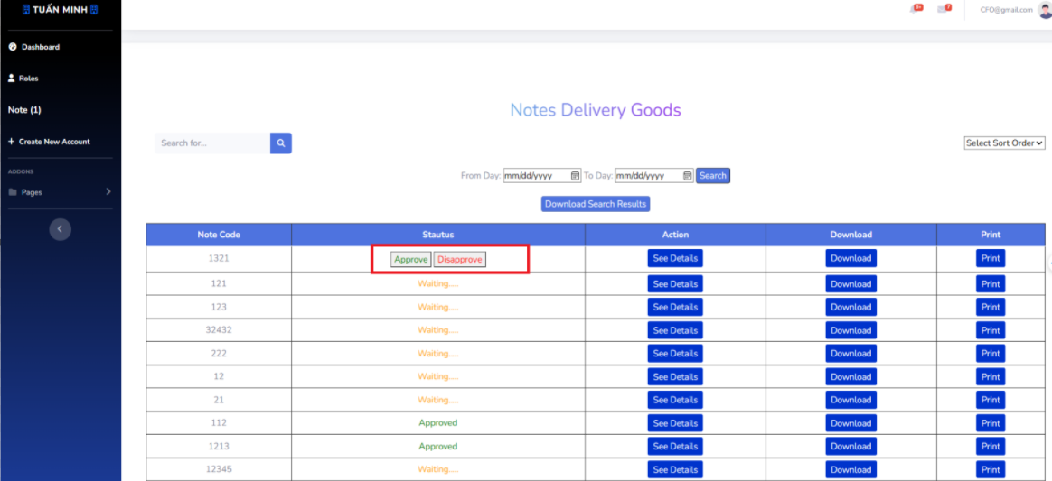

* **Creating and Setting Roles for a New Account**: As a CFO, you also have the ability to create new accounts and set their roles. To do this, navigate to the “Accounts” section using the navigation bar on the left side of the page. Once there, click the “Create New Account” button. This will take you to a new page or pop-up window where you can enter the account’s details and set its role.

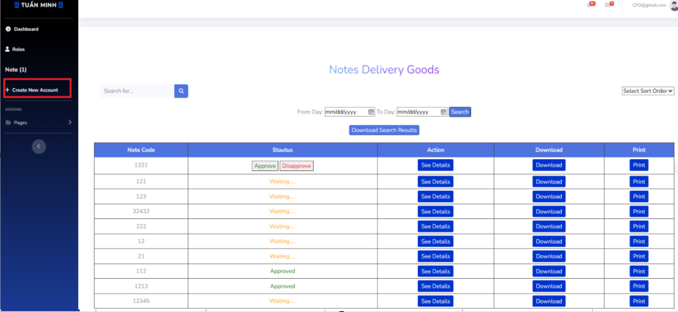

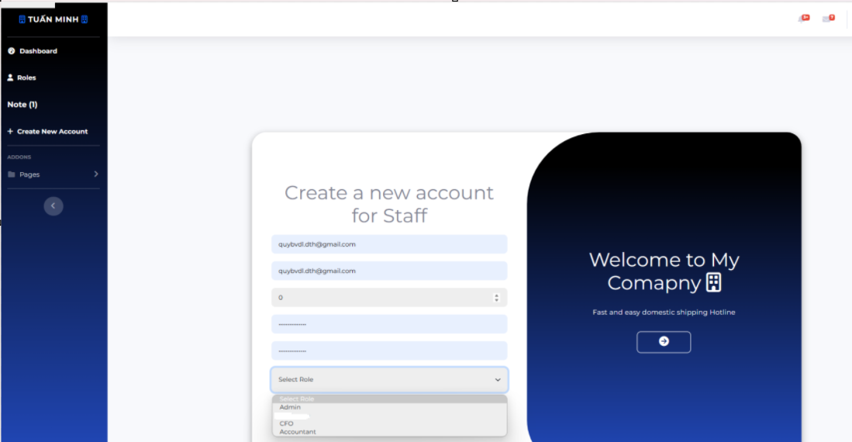

**IV. Conclusion**

* In essence, this document serves as a comprehensive guide designed to empower users with the knowledge and understanding necessary to effectively navigate and utilize this project. It meticulously details the functionalities of the project, providing users with step-by-step instructions and insights into each feature.
* From the initial setup encapsulated in the "Deliverable Package" and "Installation Guides", users are introduced to the fundamental components of the project. This ensures a smooth and seamless setup process, paving the way for a user-friendly experience right from the start.
* The heart of the document, the "User Manual", delves into the core functionalities of the project. It breaks down complex workflows into manageable steps, demystifying processes such as managing products, warehouses, categories, and customers. It also provides a deep dive into the intricacies of note management, catering to various roles such as the Keeper, Accountant, and CFO. Each workflow is explained with clarity and precision, making it easy for users to understand and apply in their interactions with the system.
* Finally, this document is more than just a manual; it's a roadmap to successful interaction with the project. It equips users with the necessary tools to explore, understand, and make the most of the system, ultimately enhancing their overall experience. Whether you're a novice user or an experienced professional, this document is designed to help you navigate the project with ease and confidence.